Fitness Center Locker Rooms

Cherokee Nation Businesses along with Cherokee Nation Property Management is seeking qualified General Contractors to provide labor and materials for refurbishment of the existing Fitness Center Locker Rooms on the 2nd Floor in Williams Tower II in downtown Tulsa, Oklahoma. Selected firm will work with Cherokee Nation Businesses Corporate Construction and Property Management on issues or concerns and access as necessary.
Fees
The fee is to be a lump sum cost. The cost is to be all inclusive and is to broken down into Labor and Materials.

Scope of Work
The work will consist of the removal and replacement of cabinets, counter tops, patching of walls, painting fixtures, lighting based on the items listed below.

1.Demolition
The contractor shall remove the existing cabinets located on top of the existing countertops. Existing countertops shall be demolished and removed while leaving the existing framing in place.
The contractor shall also remove the existing vanity lights and seven existing mirrors.

2.Wall Patching and Painting
The contractor shall patch walls as required where existing items are removed.
Painting shall be limited to wall areas disturbed by construction.

3.Countertops and Laminate
The contractor shall install new laminate on the existing framing skirt.
The contractor shall furnish and install new Wilsonart 3cm quartz countertops — River Glen Q4053 in each locker room.

4.Mirrors and Lighting
The contractor shall furnish and install (7) new Kohler K-26052-BGL mirrors.
The contractor shall furnish and install (7) new Nyra 25 bath fixtures.

5.Plumbing Fixtures
The contractor shall furnish and install (6) new undermount sinks and (6) single-handle deck-mount faucets.
New sinks and faucets shall be connected to the existing water and drain piping.

6.Plumbing Modifications and Accessories
The contractor shall install lavatory trap and supply covers.
The contractor shall rework the water and drain lines from the wall as required for the new sinks and shall provide traps and stops for the new sinks if required.

7.Hallway Pendant Fixtures
The contractor shall remove (3) existing suspended chain-hung hallway fixtures.
The contractor shall install (3) new Kuzco Anello 19" pendant fixtures in their place.
Please see below for the pictures and links of the fixtures we will be using.
- Mirrors: https://www.kohler.com/en/products/mirrors-and-medicine-cabinets/shop-mirrors-and-medicine-cabinets/essential-22-x-34-rectangle-decorative-mirror-26052?skuId=26052-BLL

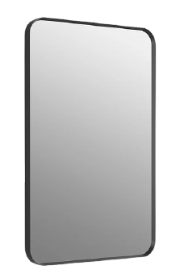

- Locker Room Lighting Fixture: https://www.visualcomfort.com/us/p/nyra-25-bath-700bcnyr25?selected_product=700BCNYR25B-LED930
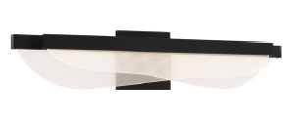
- Countertops: https://www.wilsonart.com/river-glen-q4053

- Hallway lighting Fixture: https://kuzcolighting.com/products/anello-minor-pd52719-kuzco?variant=52113864556862
