Cherokee Nation
www.cherokee.org

REQUEST FOR BIDS

RFB – MINI EXCAVATOR PACKAGE



Bid Due Date: May 15, 2026

CHEROKEE NATION
P.O. Box 948
Tahlequah, OK 74465
(918) 453-5000

CHEROKEE NATION
BID REQUEST
RFB – MINI EXCAVATOR PACKAGE

The Cherokee Nation is accepting bids from interested parties for two (2) compact hydraulic excavators, two (2) 18” and 24” buckets with quick connect and disconnect design configurations and two (2) hydraulic breaker attachments or approved equivalent equipment meeting or exceeding the specifications outlined in this bid package. Interested parties are to provide a bid to furnish product equal to or better than the specifications provided. Interested bidders must follow all directions outlined in this bid packet including the utilization of mandatory bid response sheet to be considered fully responsive.

The lowest most responsive, responsible bid will be the determining factor in awarding this bid taking Indian Preference in accordance with Cherokee Nation Policy and Procedures. The successful bidder will be issued a purchase order incorporating the bid response.

Bids are due May 15, 2026 by 3:00 p.m.

MANDATORY SUBMITTAL INFORMATION: Bid submittal requirements must be followed. Each bid must be submitted on the prescribed, required form with all areas completed. Bids may be or e-mailed to joey-ross@cherokee.org. It is the bidder’s responsibility to ensure delivery of bid by May 15, 2026 by 3:00 p.m. Any bids received after the designated date and time will be ineligible for award.

Bid Acceptance: Bids will be accepted from Indian and Non-Indian bidders. Cherokee Nation reserves the right to reject any and all bids. Cherokee Nation reserves the right to determine if a bid meets stated requirements, and to award a purchase order for the bid that is in the best interest of the Cherokee Nation including but not limited to the total cost and capability of the bidder. Bidders are responsible for any and all costs associated with the preparation and submission of bids. To be considered, bids must be received by the specified date and time; any bid received after stipulated date and time will be returned unopened. No bidder may withdraw their bid within 30 days after proposal due date.

TERO Certification: Indian preference will be given only to bidders who provide proof of current certification from the Cherokee Nation Tribal Employments Office (TERO) located in Tahlequah, Oklahoma, telephone number (918) 453-5000. Proof of TERO certification must accompany and be included in bid submittal.

Conflict of Interest and Restrictions: If any contractor, contractor’s employee, subcontractor, or any individual working on the proposed contract may have a possible conflict of interest that may affect the objectivity, analysis, and/or performance of the contract, it shall be declared in writing and submitted to Cherokee Purchasing Department (Attn: Joey Ross) no later than on or before May 15, 2026 by 3:00 p.m. The NATION will determine in writing if the conflict is significant and material and if so, may eliminate the contractor from submitting a proposal.

Verbal Instructions: Interested parties shall not initiate or execute any negotiation, decision, or action arising from any verbal discussion with any Cherokee Nation employee. Only written communications from the designated Contact Person at Cherokee Nation may be considered a duly authorized expression on behalf of the NATION regarding this RFB. Additionally, only written communications from interested parties are recognized as duly authorized expressions on behalf of the vendor. The same instructions shall apply to any subsequent award and agreement communications.

Qualifications of Bidder: The NATION may make such investigations as deemed necessary to determine the ability of the bidder to perform the work, and the bidder shall furnish to the NATION all such information and data for this purpose as the NATION may request. The NATION reserves the right to reject any bid if the evidence submitted by, or investigation of, such bidder fails to satisfy the NATION such bidder is properly qualified to carry out the obligations of the contract and to complete the work contemplated therein. Conditional bids will not be accepted.

Buy American – Recovery Act provisions: The buy American provisions direct that all of the iron, steel, and manufactured goods used in the project are produced or manufactured in the United States for a project for the construction, alteration, maintenance or repair of a public building or public work. This Buy American provision is applicable only to iron, steel, and manufactured good brought to the construction site for incorporation into a public building or public work. Products that do not fit the definition of manufactured goods are not covered.

Method of Award – Lowest Bid That Contains Lowest Most Responsive/Reasonable Offer From Qualified Bidder: After consideration of price and other factors, the purchase order will be awarded to the bidder whose bid is determined to be the lowest most responsive/reasonable offer taking Indian Preference into consideration and in the best interest of the Nation to accept. Award shall be to the lowest, most responsive/reasonable bid in accordance with Cherokee Nation Policy and Procedures. Indian/TERO Preference will be given only to bidders who provide proof of current TERO certification from the Cherokee Nation Tribal Employments Office (TERO) in accordance with current Cherokee Nation Policy. Proof of TERO certification must accompany and be included in bid submittal.

Debarment, Suspension, Proposed Debarment, and Other Responsibility Matters: The responding party certifies to the best of its knowledge and belief that the person, the firm, or any of its principals are not presently debarred, suspended, proposed for debarment, or declared ineligible for the award of contracts by any Federal agency or Indian tribe. The bidder will also certify they have not, within a three-year period preceding this Request for Proposal, been convicted of or had a civil judgment rendered against them for: commission of fraud or a criminal offense in connection with obtaining, attempting to obtain, or performing a public (Federal, State, Local or Tribal) contract or subcontract; violation of Federal or State antitrust statutes relating to the submission of offers; or commissions of embezzlement, theft, forgery, bribery, falsifications or destruction of records, making false statements, and are not presently indicted for, or otherwise criminally or civilly charged by a governmental entity with, commission of any of the offenses enumerated in this provision. The responding party certifies they have not, within a three-year period preceding this Request for Proposal, had one or more contracts terminated for default by a Federal, State, Local or Tribal agency. The responding party shall provide immediate written notice to the Cherokee Nation if, at any time prior to contract award, the person learns its certification was erroneous when submitted or has become erroneous by reason of changed circumstances.

General Information: Cherokee Nation reserves the right to waive any informalities or to reject any and all bids. Award of purchase order will be to the lowest most responsible responsive bidder and will be subject to availability of funds. All sums due to any suppliers utilized by successful bidders must be paid or will be paid within ten (10) days of receipt of any money received from the Cherokee Nation under any purchase order. Indian preference will be given to Contractors certified as an Indian-Owned firm by the Cherokee Nation Tribal Employment Rights Office (T.E.R.O.). Proof of certification must accompany all bids. No bidder may withdraw their bid within thirty (30) days after bid opening date.

A prospective contractor seeking to receive Indian Preference under this contract must be certified as an Indian-owned firm by the Cherokee Nation Tribal Employment Rights Office (TERO) and submit proof of that certification with their bid.

MANDATORY BID RESPONSE SHEET
RFB – MINI EXCAVATOR PACKAGE

Product Description QTY UNIT COST TOTAL

Compact Hydraulic Excavator 2 ___________ ____________

18” & 24” buckets w/Quick Connect 2 ___________ ____________

Hydraulic Breaker Attachment 2 ___________ ____________

Total Trade In Value 1 ___________ ____________

GRAND TOTAL BID $___________________

LEAD TIME ARO: ___________________________________________

ALL SPECIFICATIONS ARE FULLY MET: ______ YES _____NO

PRODUCT SPECIFICATIONS INCLUDED: _____ YES _____NO
**Cherokee Nation will consider bids for product equal to or better. If not bidding exact product, complete details and specifications for product must be submitted with bid.**

NOTE TO BIDDERS REGARDING INDIAN PREFERENCE:

TERO Certified Contractor: _____ Yes _____ No
(Proof of certification must accompany all bids)

SUBMITTED: ________________________________________________
Company Name

________________________________________________
Company Address

________________________________________________
Authorized Signature

________________________________________________
Print Name & Title
Product Specifications and Requirements
Provided by: Cherokee Nation Transportation and Infrastructure

Equipment Procurement Bid Package

Section 1 – General Procurement Notice

The Cherokee Nation is soliciting bids for the procurement of two (2) compact hydraulic excavators, two (2) 18” and 24” buckets with quick connect and disconnect design configurations and two (2) hydraulic breaker attachments or approved equivalent equipment meeting or exceeding the specifications outlined in this bid package in Section 3 – Mini Excavator Bid Specification and Section 4 – Hydraulic Breaker Bid Specifications.

The proposed equipment shall be new, unused, and fully compatible for operation together and as specified in Section 2 – Vendor, Warranty and Deliverable Specifications.

As part of this procurement, the Cherokee Nation intends to include a trade-in of two (2) existing compact hydraulic excavators model# CAT 305.5e and two (2) existing hydraulic breaker attachments. Bidders shall evaluate the equipment offered for trade-in and include the trade-in value within their proposal submission. The trade in equipment may be viewed in person on Monday May 11, 2026 between 9:00am and 3:00pm at 13578 Hwy 51 Tahlequah, OK 74464. Photos are also attached to this bid packet.

Section 2 – Vendor, Warranty and Deliverable Specifications
Vendor Submission Requirements

Bidders shall submit a complete proposal including the following:
- Vendors contact information and authorized representative.
- Equipment manufacturer, model number, and detailed specifications for proposed equipment.
- Documentation verifying that proposed equipment meets or exceeds the performance specifications listed in this bid package.
- Itemized pricing for each piece of equipment.
- Trade-in valuation for the equipment offered by the Cherokee Nation.
- Estimated delivery timeline.

Warranty and Delivery Requirements

The vendor shall provide:
- Standard manufacturer warranty documentation for all equipment supplied.
- Expected delivery timeframe after award of contract.
- Any available service agreements or extended warranty options.
- Confirmation that equipment will be delivered fully operational and ready for use while repairing or replacing any equipment in a timely manner upon found issues with delivered equipment.
Section 3 – Mini Excavator Bid Specification
Compact Hydraulic Excavator – Performance Specification

1. Engine
- Diesel engine meeting current emissions standards.
- Turbocharged configuration required or equivalent performance design.
- Net engine power: 55.9 HP minimum
- Gross engine power: 57.9 HP minimum
2. Hydraulic System
- Load-sensing hydraulic system with variable displacement piston pump or equivalent system.
- Hydraulic pump flow capacity: 173 L/min (46 gal/min) minimum
- Maximum operating pressure:
  - Equipment / travel: 245 bar (3,553 psi) minimum
  - Swing system: 210 bar (3,046 psi) minimum
3. Work Tools / Attachment Capability
- Machines shall be attachment-ready for multiple hydraulic work tools.
- Machines must support attachments including but not limited to:
  - Hydraulic thumb
  - Hydraulic Hammer
  - 2 Excavation buckets, 18” and 24” included in quote

4. Blade
- Front dozer blade required.
- Blade configuration: angled blade
- Blade width: 78 in (1,980 mm) minimum
- Maximum digging depth: 24 in (600 mm) minimum
5. Undercarriage
- Track shoe width: 16 in (400 mm) minimum
- Acceptable track types:
  - Steel tracks w/ rubber pads
  - Rubber tracks
6. General Requirements
- Equipment shall meet or exceed all specifications listed above.
- Any proposed substitution must include documentation verifying compliance with the listed specifications.
- Equipment shall be suitable for municipal, construction, and infrastructure maintenance operations.
- Open ROPS (Roll over Protective Structure)

Section 4 – Hydraulic Breaker Bid Specification

Hydraulic Breaker Attachment – Performance Specification

1. General
- Hydraulic breaker attachment designed for use with compact construction equipment including mini excavators and similar carriers.
- Breaker must meet or exceed the performance specifications listed below.
- Have quick connect capabilities using a “S” type bracket interface and associated jumper lines.
2. Operating Weight
- Operating weight: 571 lb (259 kg) maximum
3. Performance
- Impact frequency: 500 – 900 blows per minute (bpm)
- Energy class: 501.5 ft·lbf (680 J) minimum or equivalent.
4. Tooling
- Tool shaft diameter: 2.7 in (68 mm) minimum
- Breaker tool shall be compatible with standard demolition and rock-breaking applications.
5. Hydraulic Requirements
- Hydraulic flow requirement: 10.6 – 18.5 gpm (40 – 70 lpm)
- Operating hydraulic pressure: 1,775 psi (108 bar)
6. Dimensions
- Overall length with tool installed: 17.3 in (440 mm) maximum
- Overall height with tool installed: 54.1 in (1,375 mm) maximum
7. Compatibility
The breaker shall be compatible with carrier equipment including, but not limited to:
- 4 – 9 ton mini excavators
- compact track loaders
- skid steer loaders
- backhoe loaders
Equivalent carrier equipment meeting the hydraulic and mounting requirements will be considered acceptable.
8. Design Features
- Two-piece internal design consisting of piston and valve configuration, or equivalent system designed for efficient energy transfer.
- Equipped with field-replaceable bushings to simplify maintenance and reduce downtime.
- Breaker body shall include a flat-top mounting configuration or similar design allowing multiple bracket options and flexible installation on compatible carriers.

Trade In Item #1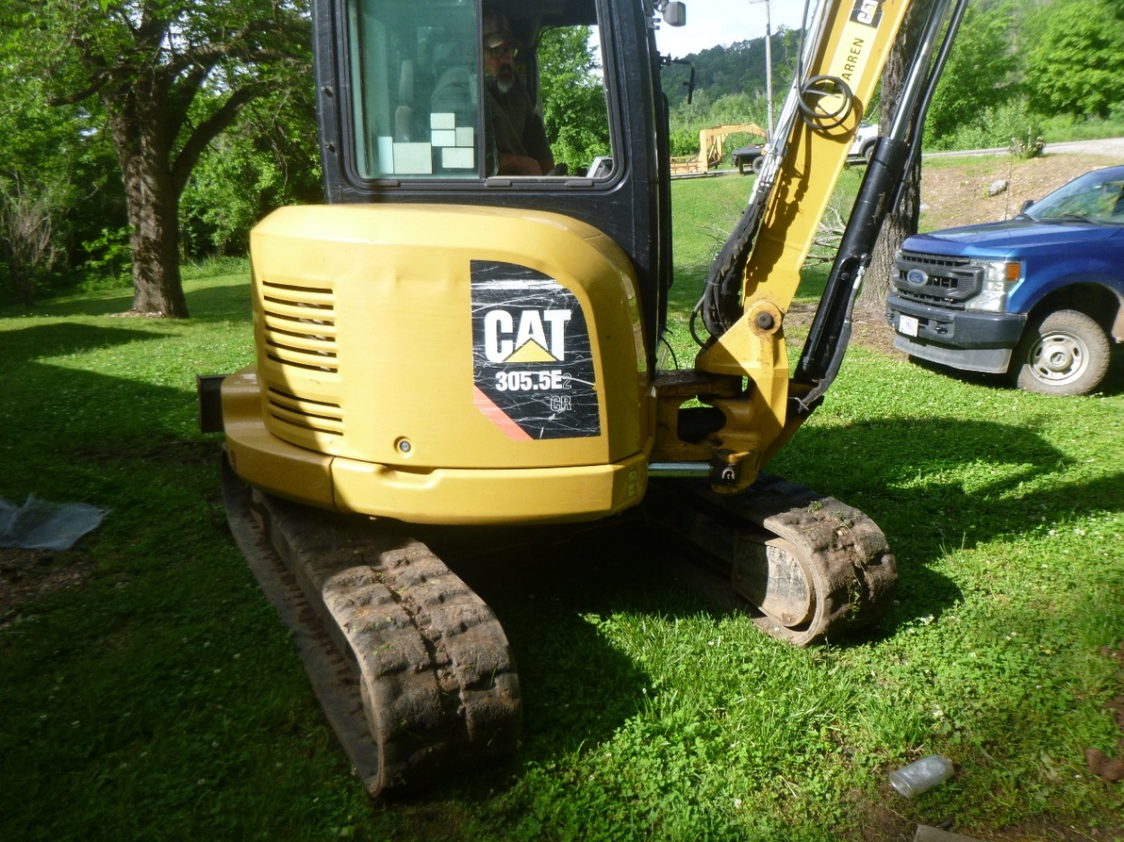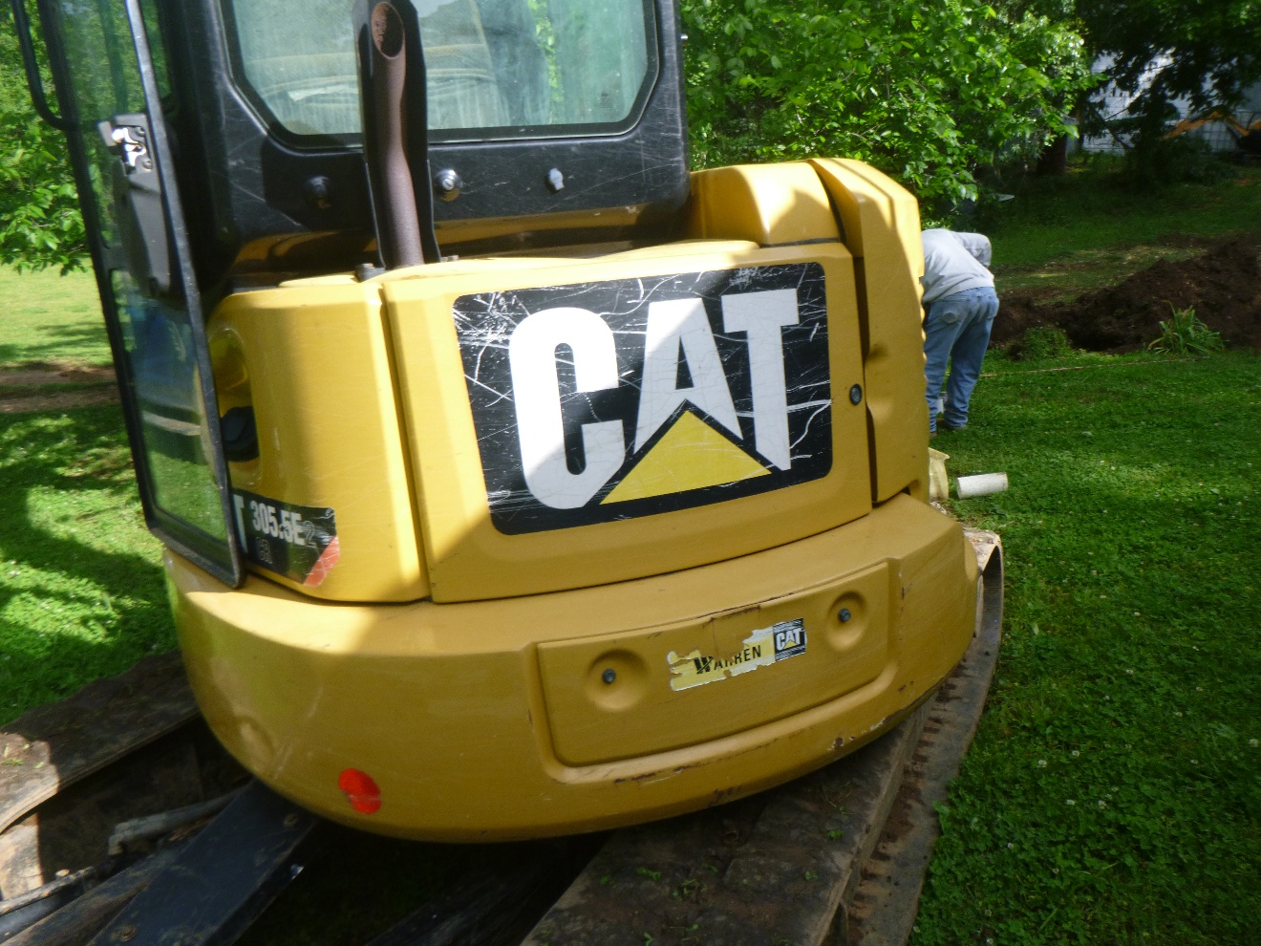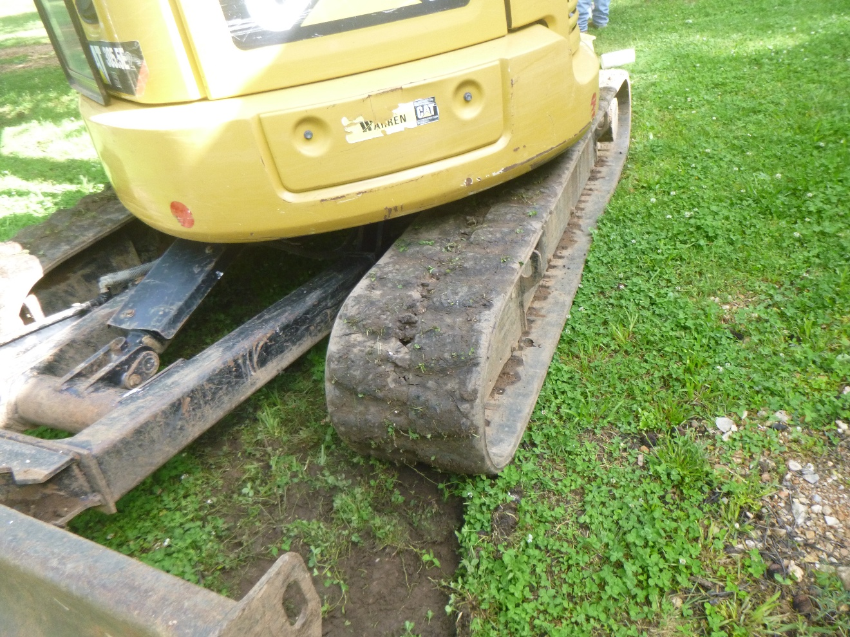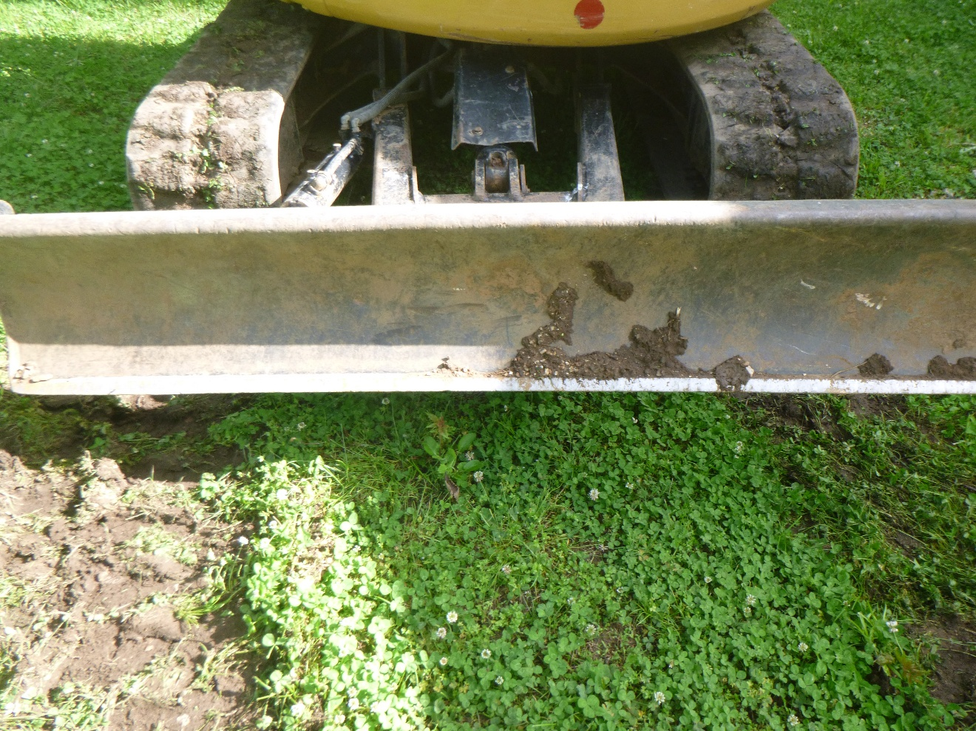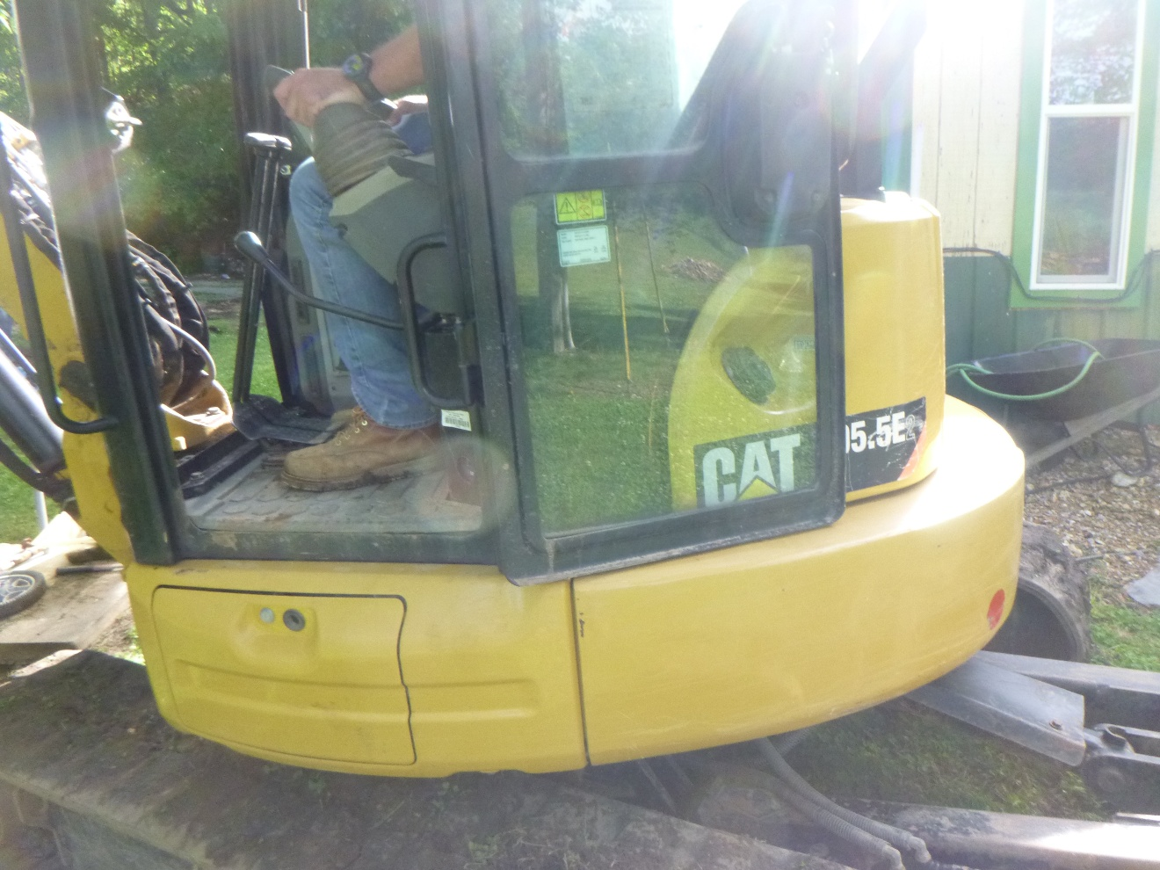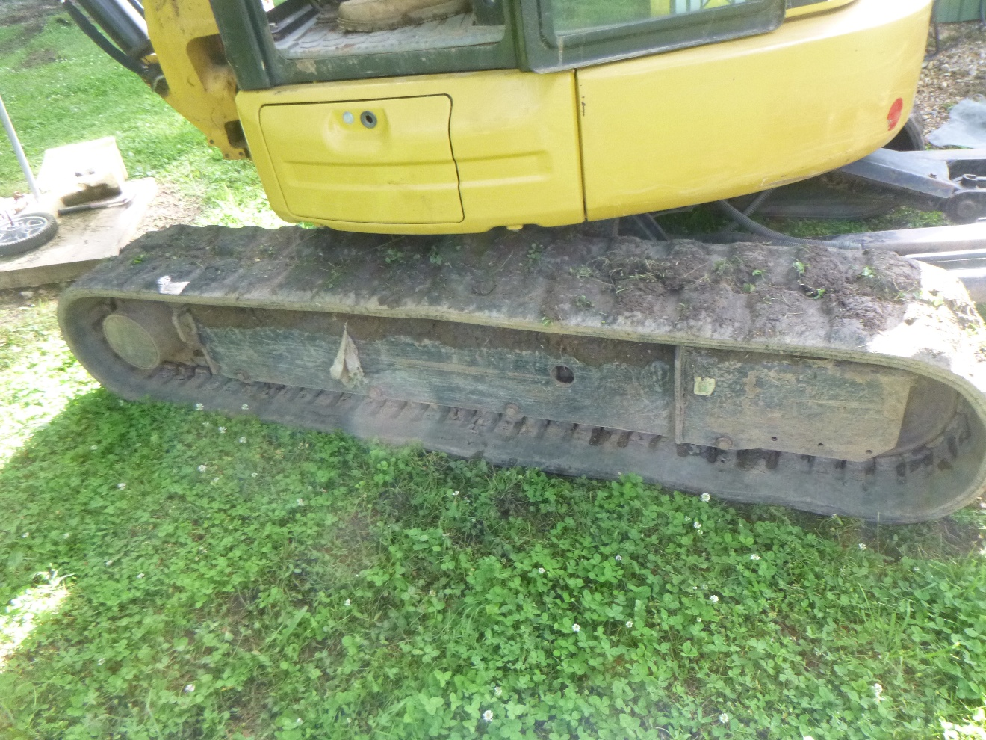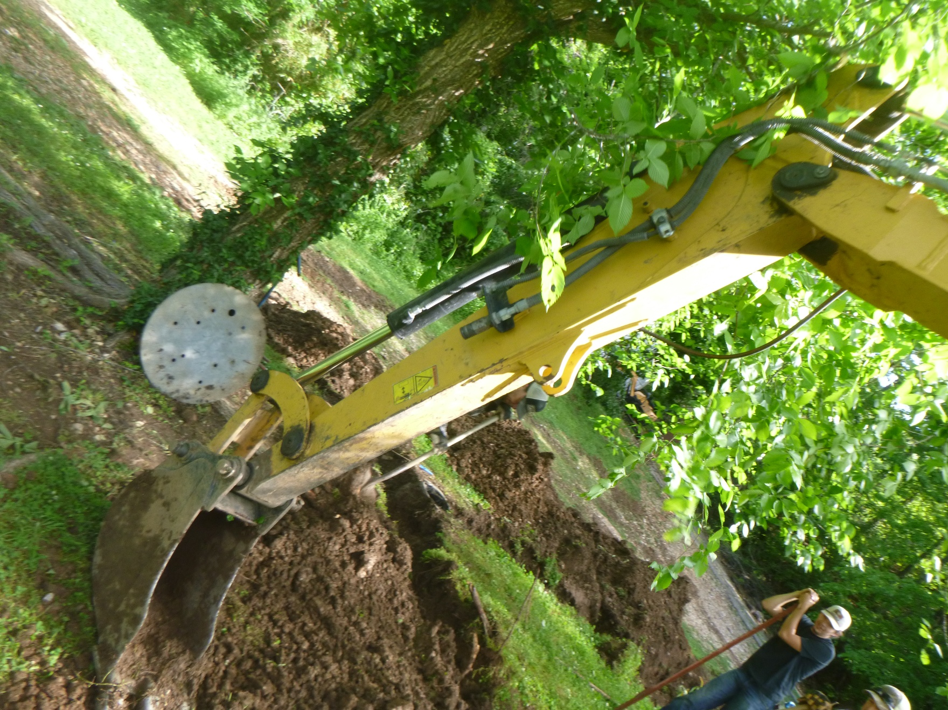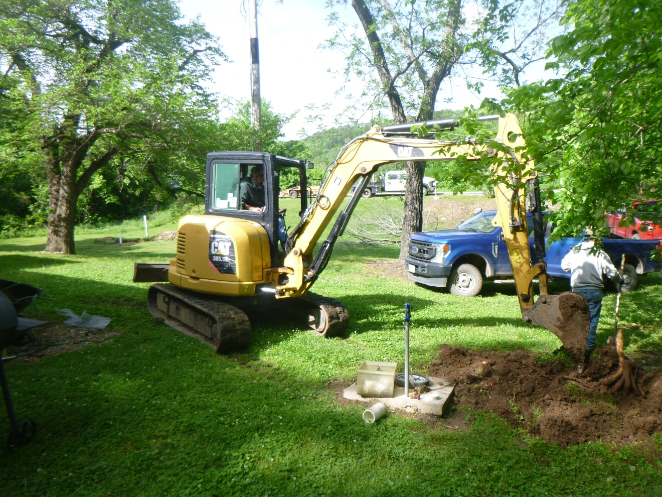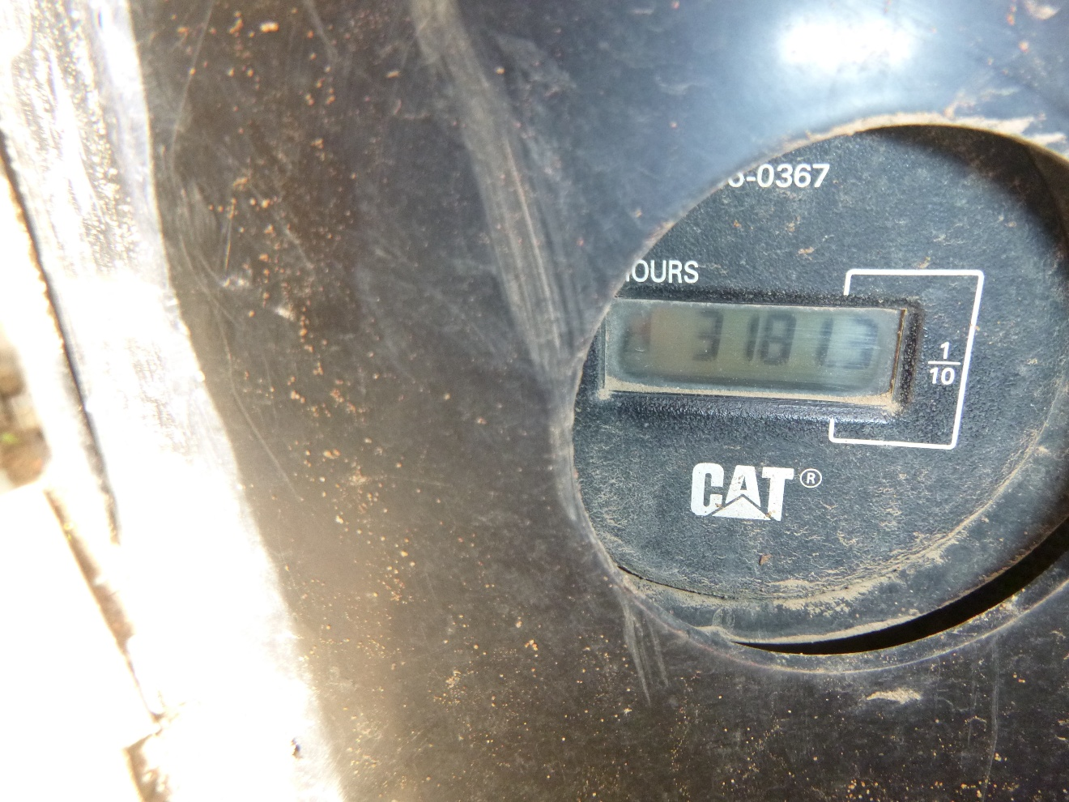
Trade In Item #2