Cherokee Nation Entertainment, LLC. (CNE), a wholly owned tribal company of the Cherokee Nation, is seeking proposals from qualified bidders for:

Steakhouse Walk-in Refrigerator Refrigeration System Placement

- Replace Unit Cooler with a Heatcraft intelliGen.
- Install oil trap on suction outlet of unit cooler.
- Replace Water Cooled Condenser with Coaxial Tube-in-Tube, Spiral, Water-Cooled Condenser.
To include:
    - Water regulating valve.
    - Inlet and Outlet Ball Valves.
- Replace Suction Line Filter with Sporlan SF-287-T
- Replace Liq. Line Filter/Dryer with Sporlan Catch-All C-163-S.
- Replace Sight Glass with Sporlan See-All SA-13S and mounted vertically (currently horizontal).
- Recover R-404A.
- New refrigerant is to be R-448A.
Fixture Dimensions: 110L X 85W X 97H
Fixture Temperature 35°F
Product: Mixed – high usage.
Evaporator Design Specifications:
Original Evaporator was a Heatcraft ADT-090
Suction (Evaporating) Temperature 25°F
Refrigerant R-404A (Replace with R-448A)
120 Volts A/C
7/8” Suction Line
3/8” Liquid Line
Condenser Design Specifications:
Original Condenser was a Standard Refrigeration ELT150A
Condensing Temperature 105°F
Water Supply Temperature 85°F
Supply Line Sizes:
1/2" Compressor Discharge Line
3/8” Refrigerant Liquid Line
5/8” Water Inlet
1/2” Water Outlet
Compressor: Copeland ZB10KCE-PFV: 1.3 HP / 12,200 BTUH / 208-1-60

Engineering specs on last page.

Contact Buyer with any questions.

All bids are due by 5:00 PM, February 17, 2026.

PLEASE SUBMIT BIDS TO: Rebecca Gautney , email rebecca.gautney @cnent.com. Bids received after the bid closing will be rejected. It is the intention of Owner that if an acceptable proposal is received, the selected firm will be notified in writing within 10 business days of bid opening. Any bid received after the time set for opening of Bids, shall not be considered and will be returned. It is the intention of CNE that if an acceptable bid is received, the Contract will be awarded by within 30 days of bid opening. Please note that winning bid(s) will be published. CNE reserves the right to issue one award, multiple awards, or reject all bids. All bids are subject to negotiation prior to award. Awards may be issued without discussion of bid received, and bids should initially be submitted on the most favorable terms from price and technical standpoint. Any award resulting from this Bid/Proposal will be subject to CNE Terms and Conditions. Your bid should indicate hourly ($) rate (when applicable), individual work effort, delivery schedule or time of completion. Any item(s) with exceptions, substitutions, exclusions, additions or qualifications must be noted and clearly indicated on return bid.

This procurement is subject to Cherokee Nation Tribal Employment Rights Office (“TERO”) regulations that include a fee of ½ of 1% of total contract award and, if applicable, the completion of a TERO Labor Agreement and payment of associated fees. The successful bidder’s award will be published on the Cherokee Nation’s procurement website and their performance will also be measured, recorded, and reported to the Cherokee Nation. The complete Act is available by contacting the TERO OFFICE at Tahlequah 918-453-5000. TERO bidders are required to provide a copy, front and back, of their TERO certificate with return bid(s) and failure to do so will result in such bidders not receiving the TERO preferences afforded TERO bidders under the CNE procurement and contracting policies and procedures.

Engineering:

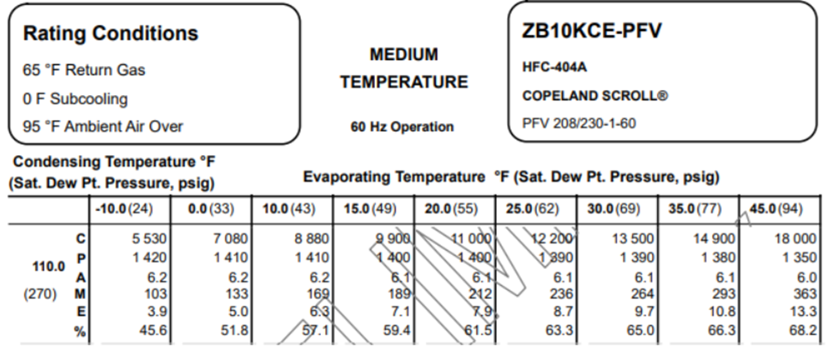

CHEROKEE NATION GAMING COMMISSION (CNGC) - This requirement may be subject to CNGC policies and procedures. Licensing requirements may be required of the successful vendor(s) to be coordinated with the CNGC. These requirements may include licensing fees as well security and background checks of vendor(s) employees. Current policies and procedures can be found on the Cherokee Nation website or by contacting the CNGC office at 918-431-4116.

BONDING NOTICE CNE generally requires payment and performance bonds for all construction contracts in excess of $100,000. However, qualified TERO-certified firms are encouraged to bid, regardless of bonding capability.

By submitting a response to this Request for Proposal, the Contractor certifies to the best of their knowledge and belief that the Subcontractor, the firm, or any of its principals are not presently debarred, suspended, or proposed for debarment by any federal, state, local or tribal entity. This certification is a material representation of fact upon which reliance was placed when making award. If it is later determined the Subcontractor rendered an erroneous certification, in addition to other remedies available to CNB or its entities, CNB may terminate the contract resulting from this Request for Proposal for default.

In accordance with Cherokee Nation Law, 28 C.N.C.A. §20 no contractors or subcontractors of any Cherokee Nation entity may contract with any business owned by a first degree relative of any elected official of the Cherokee Nation.

