Small Swag Scope of Work
Hard Rock is looking for 5000 of each of the below items. Items needed to be logoed. Logo will be one color one location. Delivered by December 15th, 2026. All items are open to vendor selection. We are genuinely open to all options and colors.

Items we are requesting
- Silicone Shot Glass 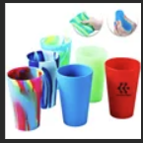
- Ice Scrapper 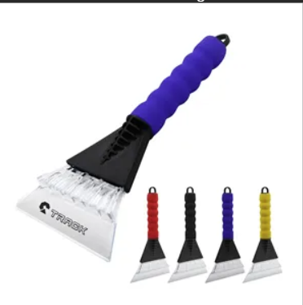
- 2027 Calendars 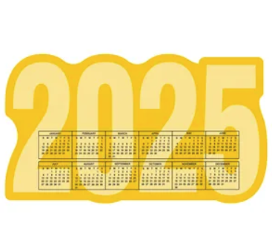
- Hand Warmers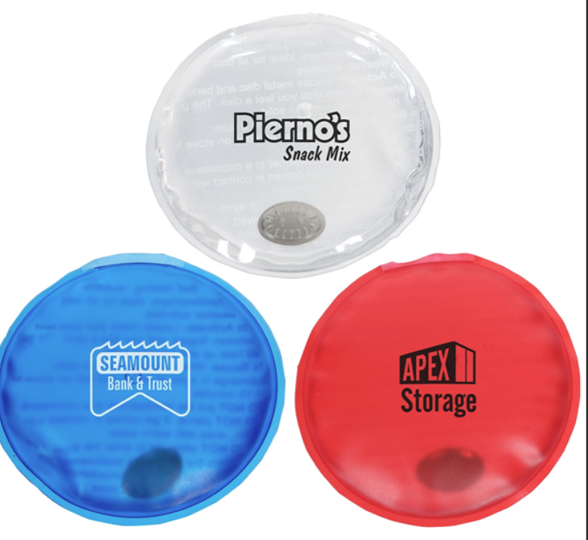

- Lip Balm- Vanilla Flavor
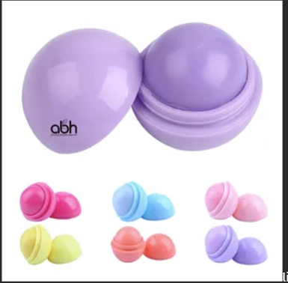

- Slap Koozies
