Statement of Work
Date | 9/19/2025
Client | Cherokee Nation Entertainment (CNE)
Job Name | Indoor Lighted Signs
Requested by | Carla Davies
Summary
Cherokee Nation Entertainment is requesting bids for 3 interior lighted signs for our West Siloam Springs property.

SCOPE OF SERVICES

Design and Manufacture and Install – Using the below pictures and logos

- 1 Collective Kitchen Sign

- 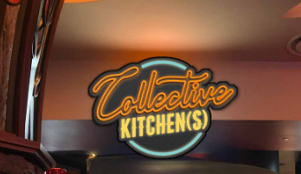

- 1 Dough Mama’s Sign
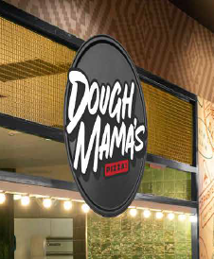

1 Jade Sign

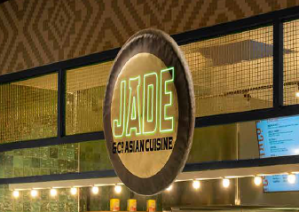

Area Picture

