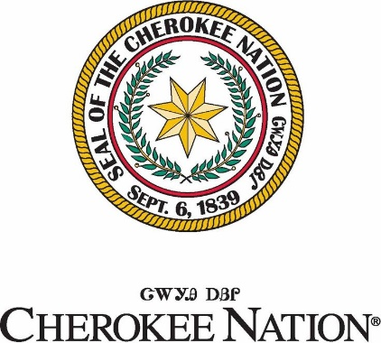

**Request for Art Bid**

**Original Art**

Cherokee Nation Child Development Center – Sallisaw, OK

**Summary**

Cherokee Nation Cultural Economic Development (CED) is currently accepting digitally submitted bids for 2D art to be displayed at the Sallisaw Child Development Center in Sallisaw, OK.

The Sallisaw Child Development Center is a newly constructed, one-story facility with a total area of 32,515 square feet that will feature 12 classrooms including four dedicated infant care classrooms. The center will be built south of the Redbird Smith Health Center.

LA 25-05 requires all Cherokee Nation construction and/or renovation projects $500,000+ to set aside 1% of the total project cost for the procurement of culturally appropriate art. The use of these funds allows the Cherokee Nation to share our rich history, culture and heritage through visual art.

CED only accepts bids from Cherokee Nation citizens who can provide identification as such, and artists previously designated as Cherokee National Treasures.

**Description**

The center is seeking original artwork to be displayed on the walls of the new facility. Artwork may be related to, but is not limited to, the following:

* Cherokee traditional stories
* Animals and plants important to Cherokee history and culture
* Depictions of the seven clans
* Depictions of Cherokees throughout history – from time immemorial to present day
* “Child Friendly” Art
* Large scale flat art

**REQUIREMENTS:**

* Artists’ submissions should include image of artwork, dimensions, medium, and price. A form will be provided for each digital submission.
* Artists are allowed to submit a maximum of 20 pieces.
* No personal photography will be accepted.
* Artists that submit their work with syllabary will be subject to having our translation team review for accuracy.
* Artists’ work will be subject to a review of cultural authenticity.
* If artwork is created with A.I. (Artificial Intelligence) please describe how it was used in the description of the bid form.
* It is the artist’s responsibility to mail or deliver the art if selected.
* We will only accept **complete** works of art.
* Any 3D art that could be framed will be accepted. This location has no 3D cases.

**Proof of Citizenship**

Cherokee Nation law requires the purchase of art from Cherokee Nation citizens only. You must submit a copy of your Blue Card or Citizenship Card when submitting an initial bid. No exceptions.

**Bid Information for submission:**

Bids must be submitteddigitallyto CED Senior Buyer, Amy Eubanks at [artbidsubmissions@cn-bus.com](mailto:artbidsubmissions@cn-bus.com) no later than **5:00 pm on Friday, June 27th, 2025**. If you have any questions, please contact Amy Eubanks at (918) 422-6593 or via email at [amy.eubanks@cn-bus.com](mailto:amy.eubanks@cn-bus.com).