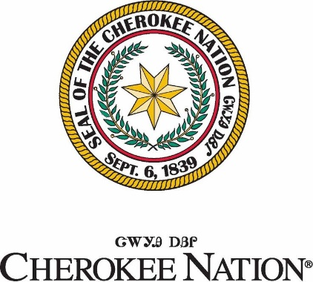

**Call for Art – “New” Cherokee Nation Hospital in Tahlequah, OK**

**Original 2D and 3D art**

Cherokee County - Cherokee Nation

**Summary**

Cherokee Nation Cultural & Economic Development is currently accepting digitally submitted bids for 3D and 2D art to enhance the beauty of the Cherokee Nation Hospital in Tahlequah, Oklahoma within Cherokee County.

 Cherokee Nation broke ground in 2024 to construct a new six-story hospital to replace the current W.W. Hastings Hospital located in the CN capital. The new hospital will be located on the east side of the CN Outpatient Health Center and encompass 400,000 square feet of space with a connecting bridge to the outpatient center. It will have space for 127 patient beds, a helipad, a neo-natal ICU, surgery center, dialysis area and hospice care.

LA 25-05 requires all Cherokee Nation construction and/or renovation projects $500,000+ to set aside 1% of the total project cost for the procurement of culturally appropriate art. The use of these funds allows the Cherokee Nation to share our rich history, culture and heritage through visual art.

Cherokee Nation Cultural & Economic Development only accepts bids from Cherokee Nation citizens who can provide identification and artists previously designated as Cherokee National Treasures.

**Description**

Artists are encouraged to submit artwork related to Cherokee history, culture, and heritage. Artwork that includes cultural or historical elements, including but not limited to historic figures, clothing, language, and symbolism should be historically and culturally accurate. Artists are also encouraged to submit artwork in contemporary styles and mediums.

Example themes may include, but are not limited to the following:

* Cherokee traditional stories
* Animals and plants important to Cherokee history and culture
* Depictions of the seven clans
* Traditional cultural practices such as stickball, marbles, stomp dance, etc.
* Traditional southeastern symbolism
* Cherokee language
* Interactions between multiple generations
* Contemporary themes

**REQUIREMENTS**

* Artists’ submissions should include image of artwork, dimensions, medium, and price. A form will be provided for each digital submission.
* Artists are allowed to submit a maximum of 20 pieces.
* No personal photography will be accepted.
* Artists that submit their work with syllabary will be subject to having our translation team review for accuracy.
* Artists’ work will be subject to a review of cultural authenticity.
* If artwork is created with A.I. (Artificial Intelligence) please describe how it was used in the description of the bid form.
* It is the artist responsibility to mail or deliver the art if selected.
* We will only accept **completed** works of art.

**Proof of Citizenship**

Cherokee Nation law requires the purchase of art from Cherokee Nation citizens only. You must submit a copy of your Blue Card or Citizenship Card when submitting an initial bid. No exceptions.

**Bid information for submissions:**

Bids must be submitteddigitallyto CED Senior Buyer, Amy Eubanks at [artbidsubmissions@cn-bus.com](mailto:artbidsubmissions@cn-bus.com) no later than **5:00pm on Friday, July 18th, 2025**. If you have any questions, please contact Amy Eubanks at (918) 422-6593 or via email [amy.eubanks@cn-bus.com](mailto:amy.eubanks@cn-bus.com).