Cherokee Nation

**www.cherokee.org**

**ADDENDUM 03 – HULBERT MARSHAL/EMS BUILDING EXPANSION**

**MARCH 17, 2025**

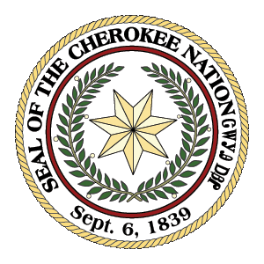

**CHEROKEE NATION**

**P.O. Box 948**

**Tahlequah, OK 74465**

**(918) 453-5000**

ADDENDUM 03- HULBERT MARSHAL/EMS BUILDING EXPANSION

[​Folder iconHulbert EMS Addition](https://blueriverarchitects-my.sharepoint.com/:f:/p/cseat/EmtUljiO-CJPq1LpXikfHYQBaWnTH4ZJJ_-O8lTgRfqSRQ?e=txXhwJ)

Highlight link, right click on mouse, and select “Open Hyperlink”; or, highlight link and select “Copy Hyperlink” and then paste into preferred browser.

SEALED BIDS DUE NO LATER THAN TUESDAY, MARCH 25, 2025 BY 2:00 P.M. CT. A PUBLIC BID OPENING WILL BE HELD TUESDAY, MARCH 25, 2025 AT 2:00 P.M. IN THE FINANCIAL RESOURCES LARGE CONFERENCE ROOM (DIRECTLY BEHIND THE MAIN COMPLEX) 17665 S. MUSKOGEE, TAHLEQUAH, OK.