**CED CULTURAL TOURISM**

**REQUEST FOR PROPOSAL**

**CN Peace Pavilion- Site Electrical Upgrades**

**PROJECT LOCATION**

The Cherokee Nation Peace Pavilion property is located at 177 East Water Street, Tahlequah, OK. The project will focus on updating the electrical systems to support larger events such as the State of the Nation address. Upgraded service and power pedestals will eliminate the need for generators and excessive power cords that have been required for past events. **This RFP is for completing only a portion of the scope of work identified on the referenced plans. A subsequent RFP for completing the major improvements shown in these plans will be issued at a later date. Bidders are encouraged to review the specific scope listed herein.**

**SECTION A: GENERAL**

**The scope of work for this bid package shall include, but is not necessarily limited to the following general items:**

**Project Coordination:**

1. Contractor is to furnish subcontractors, manpower, materials, and equipment necessary, as required by the project schedule, including interim milestone dates, and to furnish additional crews, equipment, etc. and/or overtime required to maintain the schedule if Contractor falls behind due to their own fault or due to inclement weather.
2. Contractor is responsible for field engineering, layout and field layout from benchmarks or other known points on the site as directed by Owner/Architect.
3. Contractor shall furnish pumping and dewatering as required for the scope of this bid package. Any pumping performed must be done so as not to hinder any other trades’ work.
4. Contractor shall furnish drinking water for its employees.
5. Contractor shall Include all remobilization operations required to complete the scope of this bid package.
6. Contractor shall coordinate all material deliveries with the Owner and shall have a representative on site to receive all deliveries of materials under the scope of work of this bid package.
7. Contractor shall clean up his work in such a manner as to maintain safe working conditions on the project, including but not limited to excess material, lunch trash, and dirt and debris on streets and sidewalks. All trash generated from this Contractor’s work, or its’ forces shall be removed by the Contractor’s own forces and Contractor’s equipment. Trash shall be placed in an on-site dumpster provided by Owner. Any waste that requires special disposal such as concrete, pavement or hazardous waste will be disposed of by Contractor and not placed in the on-site dumpster.
8. Contractor shall conform to the Owner’s work hours.
9. Contractor shall furnish protection of adjacent surfaces and repair of any damage caused by the work of this Contractor including but not limited to trees, fences, sidewalks, and other site furnishings in the vicinity of the house.
10. The Peace Pavilion property will be closed to the public during construction. Contractor shall carefully coordinate parking and jobsite access with owner. CONTRACTOR SHALL PROVIDE TEMPORARY CHAIN LINK SAFETY FENCING AT PERIMETER OF WORK AREA WITH APPROPRIATE SAFETY SIGNAGE. WITH EXCEPTION FOR NEW PRIMARY/SECONDARY ELECTRIC SERVICE, ALL MATERIALS STAGING AND WORK SHALL BE COMPLETED WITHIN FENCED AREA. REFER TO SHEET A001 FOR PROJECT BOUNDARIES.
11. ALL AREAS DISTURBED BY THIS CONTRACTOR SHALL BE REPAIRED AND RE-SODDED.
12. DAMAGE TO EXISTING ROADS CAUSED BY CONSTRUCTION ACTIVITES SHALL BE THE RESPONSIBILITY OF THE CONTRACTOR TO REPAIR TO ORIGINAL CONDITION. CONTRACTOR SHALL COORDINATE DELIVERIES OF MATERIALS/EQUIPMENT TO PREVENT DAMAGE TO ROADS/DRIVES.
13. BIDDERS ARE ENCOURAGED TO CAREFULLY INSPECT THE EXISTING CONDITIONS OF THE STRUCTURE AND REVIEW ALL PERTINENT DRAWINGS AND REPORTS PRIOR TO BID. BIDDERS WILL BE ALLOWED ACCESS TO CRAWL SPACES AND ATTIC AREAS AT THE MANDATORY PRE-BID CONFERENCE. BIDDERS MAY CONTACT THE BUYER TO ARRANGE FOR A SITE VISIT DURING NORMAL BUSINESS HOURS.
14. INTERIOR FURNISHINGS THAT ARE NOT BUILT-IN OR REQUIRED TO BE RESTORED AS PART OF CONSTRUCTION SHALL BE REMOVED BY OWNER PRIOR TO CONSTRUCTION.

**Safety:**

1. Contractor is to provide for its employees all necessary safety and PPE as required by the authorities having jurisdiction and Owner’s standard safety policies and procedures.
2. Contractor will furnish temporary barricades, flagmen and traffic control as required for the scope of this bid package.
3. Contractor shall furnish all scaffolding, work platforms, equipment and supplies to complete all work performed under the scope of this bid package, and as required by the authorities having jurisdiction and Owner’s standard safety policies and procedures.

**Testing:**

1. Contractor will assist the Material Testing Laboratory in obtaining samples and gathering data as needed and shall notify the Owner a minimum of 24 hours in advance of testing required under the scope of work of this bid package.
2. Laboratory materials testing shall be provided by contractor in accordance with specifications.

**Administrative:**

1. Contractor will furnish all submittals, shop drawings, samples, mock-ups, and closeout documents required by the contract documents.
2. Contractor shall furnish all submittals, shop drawings, and samples within 30 days of receipt of notice to proceed.
3. Any professional engineering services required by the contract documents for the assembly of submittals and shop drawings are the responsibility of this contractor.
4. Contractor will furnish all licenses, permits, and certifications and arrange for inspections and testing as may be required by and for this Contractor’s work, and as required by the authorities having jurisdiction.

**SECTION B: PROJECT SPECIFIC SCOPE**

Contractor is to furnish manpower, materials, and equipment necessary, as required to complete the project in accordance with the contract documents including but not limited to the following plans and specifications:

* CHEROKEE NATIONAL PEACE PAVILION SITE AND LANDSCAPE ENHANCEMENTS by Alaback Design dated 1.31.25 **(NOTE: This RFP is for completing a portion of the scope of work identified on these plans. A subsequent RFP for completing the major improvements shown in these plans will be issued at a later date. Bidders are encouraged to review the specific scope listed herein)**

**The scope of work of this RFP shall include the following items, but without limiting the scope of work as provided above:**

1. **Sitework/Landscaping:**
   1. Sitework is limited to restoring lawn to original condition including repair of ruts and damage caused by construction activities.
   2. Landscaping-Contractor shall only remove plantings and landscaping features if required as part of the electrical upgrades. Contractor shall restore all landscaping beds to pre-construction condition and sod/seed any disturbed grass areas.
2. **Electrical:** 
   1. Coordinate all work with CNB Corporate Construction, TPWA, and City of Tahlequah Code Compliance.
   2. Demo existing panel feeder and associated components.
   3. Carefully trench all new circuits required for installation of electrical components to ensure minimal damage to adjacent utilities, landscaping, and hardscapes. Coordinate with Owner’s facilities staff prior to trenching to locate irrigation heads and lines. Contractor shall repair/replace any damaged utilities.
   4. Carefully sawcut all sidewalk crossings per City of Tahlequah requirements.
   5. Provide and install the following electrical systems, complete in place, in accordance with plans and specifications:
      1. Demo existing service entrance conductors and upgrade to calculated size as required by NEC.
      2. Underground branch circuitry within conduit to all pedestals and receptacles as required.
      3. Provide and install the following fixtures **only:**
         1. RV 50AMP Pedestals-2 each (CKT 17,19,20,21)
         2. P1 Recept Pedestal NW (CKT 12)
         3. P1 Recept Pedestal SW (CKT 14)
         4. P1 Recept Pedestal SE (CKT 20)
         5. P1 Recept Pedestal NE (CKT 24)

*(RV pedestal branch circuitry and overcurrent protection to be rated at 90 amps, P1 receptacles branch circuitry and overcurrent protection to be rated at 20 amps.)*

* 1. Include two (2) additional 2” PVC sleeves at all sidewalk crossings.

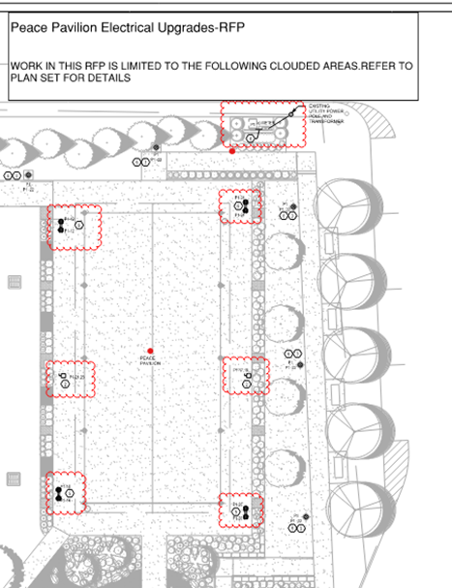

1. **ADD ALTERNATES-None scheduled.**
2. **SCHEDULE:** The Contractor agrees to complete the work within **60 calendar days** from the date of the Owner’s Notice to Proceed, free of all liens, claims, and demands of any kind for materials, equipment, supplies, services, labor, taxes, and damages to property or persons, in the manner and under the conditions specified in this RFP. Modifications to the schedule shall be made by change order to the contract following review of the request by Owner.