**CED CULTURAL TOURISM**

**REQUEST FOR PROPOSAL**

**GENERAL CONTRACTOR**

**Will Rogers Birthplace Ranch- New Caretaker Home- REBID**

**PROJECT LOCATION**

The Will Rogers Birthplace Ranch property is located at 9501 E 380 Rd, Oologah, OK 74053. This solicitation is for new construction of the New Caretaker Home (1784 SF Living/448 SF Garage) located north of the Birthplace Home Museum. The Will Rogers Birthplace Ranch Home is listed on the National Register of Historic Places. The home is a significant and vital asset of the Cherokee Nation and in a broader sense is a national treasure. The Caretaker Home will be the permanent residence of the staff supporting this property.

**SECTION A: GENERAL**

**The scope of work for this bid package shall include, but is not necessarily limited to the following general items:**

**Project Coordination:**

1. Contractor is to furnish subcontractors, manpower, materials, and equipment necessary, as required by the project schedule, including interim milestone dates, and to furnish additional crews, equipment, etc. and/or overtime required to maintain the schedule if Contractor falls behind due to their own fault or due to inclement weather.
2. Contractor is responsible for field engineering, layout and field layout from benchmarks or other known points on the site as directed by Owner/Architect.
3. Contractor shall furnish pumping and dewatering as required for the scope of this bid package. Any pumping performed must be done so as not to hinder any other trades’ work.
4. Contractor shall furnish drinking water for its employees.
5. Contractor shall Include all remobilization operations required to complete the scope of this bid package.
6. Contractor shall coordinate all material deliveries with the Owner and shall have a representative on site to receive all deliveries of materials under the scope of work of this bid package.
7. Contractor shall clean up his work in such a manner as to maintain safe working conditions on the project, including but not limited to excess material, lunch trash, and dirt and debris on streets and sidewalks. All trash generated from this Contractor’s work, or its’ forces shall be removed by the Contractor’s own forces and Contractor’s equipment. Trash shall be placed in an on-site dumpster provided by Owner. Any waste that requires special disposal such as concrete, pavement or hazardous waste will be disposed of by Contractor and not placed in the on-site dumpster.
8. Contractor shall conform to the Owner’s work hours.
9. Contractor shall furnish protection of adjacent surfaces and repair of any damage caused by the work of this Contractor including but not limited to trees, fences, sidewalks, and other site furnishings in the vicinity of the house.
10. The Will Rogers Birthplace Ranch property will be closed to the public during construction. Contractor shall carefully coordinate parking and jobsite access with owner.
11. ALL AREAS DISTURBED BY THIS CONTRACTOR SHALL BE REPAIRED AND RE-SODDED.
12. DAMAGE TO EXISTING ROADS CAUSED BY CONSTRUCTION ACTIVITES SHALL BE THE RESPONSIBILITY OF THE CONTRACTOR TO REPAIR TO ORIGINAL CONDITION. CONTRACTOR SHALL COORDINATE DELIVERIES OF MATERIALS/EQUIPMENT TO PREVENT DAMAGE TO ROADS/DRIVES.
13. BIDDERS ARE ENCOURAGED TO CAREFULLY INSPECT THE EXISTING CONDITIONS OF THE SITE AND REVIEW ALL PERTINENT DRAWINGS AND REPORTS PRIOR TO BID.

**Safety:**

1. Contractor is to provide for its employees all necessary safety and PPE as required by the authorities having jurisdiction and Owner’s standard safety policies and procedures.
2. Contractor will furnish temporary barricades, flagmen and traffic control as required for the scope of this bid package.
3. Contractor shall furnish all scaffolding, work platforms, equipment and supplies to complete all work performed under the scope of this bid package, and as required by the authorities having jurisdiction and Owner’s standard safety policies and procedures.

**Testing:**

1. Contractor will assist the Material Testing Laboratory in obtaining samples and gathering data as needed and shall notify the Owner a minimum of 24 hours in advance of testing required under the scope of work of this bid package.
2. Laboratory materials testing shall be provided by contractor in accordance with specifications.

**Administrative:**

1. Contractor will furnish all submittals, shop drawings, samples, mock-ups, and closeout documents required by the contract documents.
2. Contractor shall furnish all submittals, shop drawings, and samples within 30 days of receipt of notice to proceed.
3. Any professional engineering services required by the contract documents for the assembly of submittals and shop drawings are the responsibility of this contractor.
4. Contractor will furnish all licenses, permits, and certifications and arrange for inspections and testing as may be required by and for this Contractor’s work, and as required by the authorities having jurisdiction. The contractor will be responsible for building permits, inspection fees, sewer taps, and meeting all city/state building codes and covenants if applicable. The contractor will be responsible for temporary utilities and connecting all utilities to the home upon completion of all work.

**SECTION B: PROJECT SPECIFIC SCOPE**

Contractor is to furnish manpower, materials, and equipment necessary, as required to complete the project in accordance with the contract documents including but not limited to the following plans and specifications:

* CARETAKER'S HOME WILL ROGERS BIRTHPLACE RANCH 11/22/2024-CONSTRUCTION DOCUMENTS
* Report of Subsurface Exploration and Geotechnical Evaluation, Will Rogers Birthplace Ranch, Oologah, Oklahoma, BUILDING & EARTH SCIENCES, INC. PROJECT NO.: TU240148 PREPARED FOR: CNB Construction October 1, 2024

**The scope of work of this RFP shall include the following items, but without limiting the scope of work as provided above:**

1. **Building Pad and Site Grading:**
   1. Contractor shall provide pad prepared in accordance with geotechnical investigation and plans including stripping and stockpiling topsoil and import of fill as required to meet planned FFE. Refer to Addendum 1 of the Geotechnical report for clarification regarding pad preparation/undercuts. Provide alternate cost for shop/haybarn grading and pad work.
   2. Contractor shall be responsible for temporary roads/drives required to access the building site.
   3. Contractor shall provide all work as defined within Figure 1 “Limits of Construction” boundaries, specifically as follows:
      1. Temporarily relocate barbedwire fencing as required to complete grading and utility work. Fence shall be maintained through duration of project.
      2. Caretaker Home Pad
      3. Grading within Limits as required including import and placement of topsoil prior to laying sod.
      4. Sod with limits upon completion of Construction/excavation.
      5. Waterline to be supplied by others to within 5’ of home.
      6. Provide aerobic system, connected, complete in place.
      7. Provide transformer pad grading and wiring from Transformer to home (transformer and concrete slab provided and installed by others).
      8. Provide all sidewalks, driveway aprons, and gravel drives.
      9. Double gate is not included in this contract.

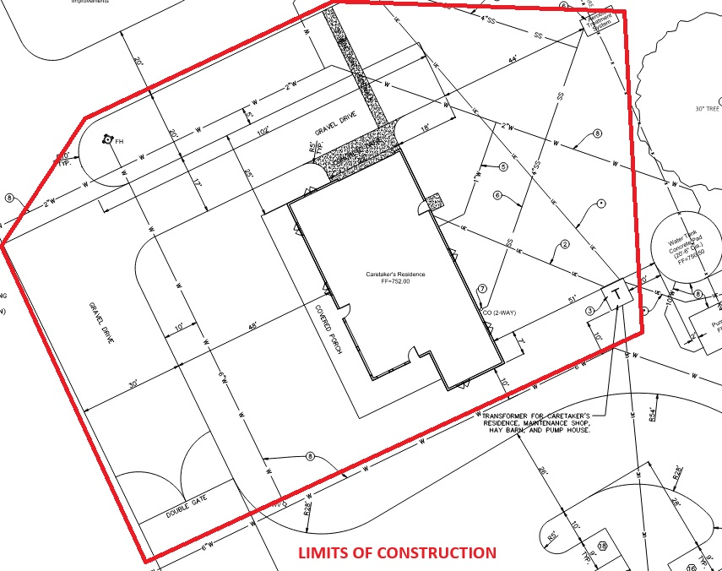

Figure 1-LIMITS OF CONSTRUCTION,PROVIDE ALTERNATE COST FOR SHOP/HAY BARN PAD

1. **Foundations & Slabs:**
   1. Excavate, reinforce, and place concrete as required to complete foundation systems per plans and geotechnical investigation. Refer to Addendum 1 of the Geotechnical report for clarification regarding pad preparation/undercuts in consideration of post-tension slab system.
   2. **All perimeter footings shown on sheet S100 shall be 2’-0” deep in lieu of 1’-6”.**
   3. Provide Termite treatment and certificate.
   4. Provide and place all sidewalks, porches, drives, and housekeeping pads as required.
   5. Post Tension Cables will be required with stamped drawings. Submit stamped reinforcement drawings for approval prior to placement.
   6. Coordinate with Owner a location for concrete washout, then haul-off all concrete washout and debris upon completion of this bid package and restore area to the condition it was in prior to this work.
2. **Masonry:** 
   1. None.
3. **Rough and Finish Carpentry:** 
   1. Complete as required per plans and specifications.
4. **Roofing:** 
   1. Contractor shall install shingles with a 30-year warranty including roof ridge vent.
   2. Decking material shall be minimum 5/8” thick.
   3. The contractor shall install Tamko Heritage Shingles, NO STAPLES, Weathered wood (or approved equal) with a 30-year warranty with 30 pound felt, slanted roof vents and flashing roof edge styled D-White. D-Style roof edge must have 1½ front edge, ¾ front edge will not be accepted. Metal or Rubber in Valleys. 5/8 Decking clips, ice, and snow shield in valley of porch.
5. **Finishes (Plaster/Paint)**:
   1. Paint as required per schedule.
   2. Paint all interior and exterior surfaces as indicated with materials specified.
6. **Flooring:**
   1. Provide and install all flooring finishes including ceramic, LVT, and stained/sealed concrete**.**
7. **Windows/Doors/Hardware:**
   1. Provide all windows, doors, frames, hardware per plans and specifications.
8. **HVAC:** 
   1. Provide complete in place HVAC systems in accordance with plans and specifications.
   2. Contractor shall provide and install Trane HVAC Equipment, 15 Seer minimum, heat pump with auxiliary resistive heat.
   3. Provide exhaust vent, heat, light combos in all restrooms. Duct work will be installed from the exhaust fan to the outside soffit with vent grill. There shall be one per bathroom.
   4. Provide floor drain in mechanical closet. Route any condensate piping to floor drain.
   5. HVAC and hot water tank will be electric. All equipment and appliances will have an Energy Star Rating, and to the greatest extent possible be “made in the USA.” Install expansion tanks at the Hot water tank location.
   6. Provide area drain at NE corner of home to serve downspout and condensate. Drain should “daylight” outside barbed wire fence using 4” flexible drain pipe.
9. **Electrical:** 
   1. Provide and install all electrical systems, complete in place, in accordance with plans and specifications for house only.
   2. Include one (1) electric outlet and one (1) empty receptacle with pullstring to attic at each bedroom for wall mount TV. Coordinate final location with owner.
   3. Include dedicated receptacle at garage ceiling for OH door opener.
   4. Ensure all receptacles in garage are GFCI rated.
   5. Include electric service from Transformer to home including trenching, boring, and backfilling as required.
   6. Transformer pad and transformer are by others and NOT included in this scope.
   7. Include temporary construction power with temp pole using existing overhead power.
10. **Furnishings-**
    1. The contractor shall furnish and install all appliances. (Matching white)
    2. Appliances:
       1. Refrigerator- minimum of 21 cubic feet with an Energy Star Rating.
       2. Electric Range will be 30” free standing and a 4 ft., 4 wire range cord with low knobs on the front of the unit below burner elevation for ADA compliance.
       3. Washer and dryer- Whirlpool High Efficiency Top-Load with Dual Action Spiral Agitator Washer & Electric Dryer Set. Hookups will be located as required and identified in the field. Dryer vented to exterior wall and the interior ducting should extend a minimum of 3” into the home to allow for easy connection to exhaust hose.
       4. Whirlpool standard white dishwasher.
       5. All Appliances must match in color (White) with an Energy Star Rating, and to the greatest extent possible be “made in the USA.”
       6. Contractor shall install a kitchen 30” vent-a-hood; vent-a-hood will be vented through the roof. Match to appliances. Wood box shall be constructed above upper cabinets to hide the vent-a-hood ducting. The box should match the cabinet material and stain finishes.
       7. Provide and install Levolor or equivalent 2” white blinds at all windows.
11. **SCHEDULE:** The Contractor agrees to complete the work within **120 calendar days** from the date of the Owner’s Notice to Proceed, free of all liens, claims, and demands of any kind for materials, equipment, supplies, services, labor, taxes, and damages to property or persons, in the manner and under the conditions specified in this RFP. Modifications to the schedule shall be made by change order to the contract following review of the request by Owner.