TAG | FURNITURE TYPE | MANUFACTURER | MODEL / DESCRIPTION | QTY | NOTES | COLOR / FINISH | Picture
B-1 | Modular Bench | Steelcase | Alight Bench | 1 | Please choose low-profile leg option  I am trying to match it to the seal. | Jungle ST167     | 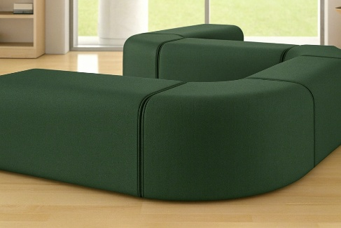 | Cost Per Item ________________________  Freight_______________________________  Delivery date _________________________
B-2 | Booth | Steelcase | Campfire Big Lounge | 1 | Match to B-1 (Jungle ST167) | Jungle ST167   | 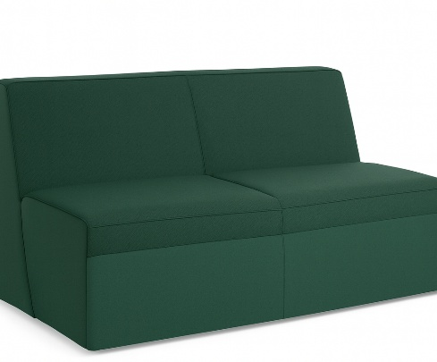 | Cost Per Item ________________________  Freight_______________________________  Delivery date _________________________
O-1 | Ottoman | Steelcase | Alight Ottoman | 1 | Please choose low-profile leg option | Jungle ST167  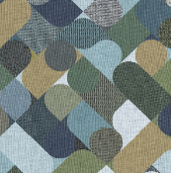 | 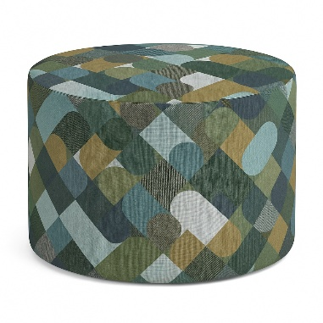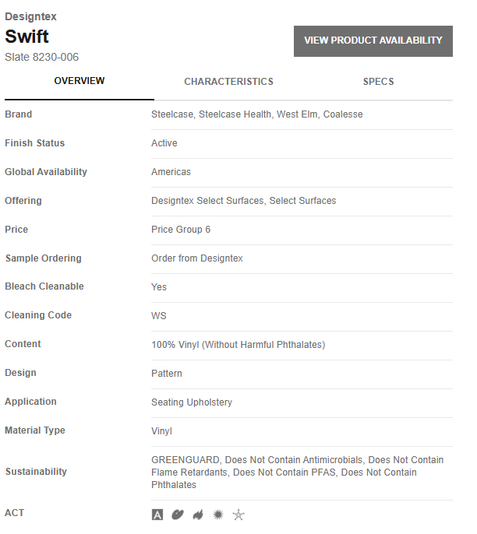 | Cost Per Item ________________________  Freight_______________________________  Delivery date _________________________
CH-3 | Lounge Chair | AXIA | 4-Set Modern Accent Chair PU Leather Barrel Armchair | 4 | — | Coffee   | 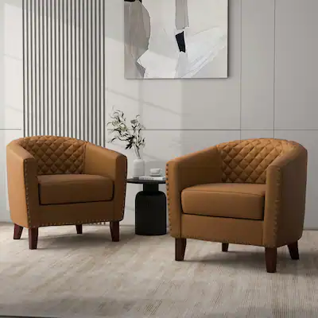 | Cost Per Item ________________________  Cost x 4 _______________________________  Freight_______________________________  Delivery date _________________________
BC-1 | 16” Bunching Bookcase w/ Door | Intercon | DK-HO-1632BD-RFO-C (Drake Collection) | 8 | — | Rustic White & French Oak | 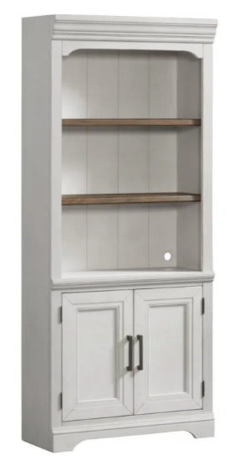 | Cost Per Item ________________________  Cost x 8 _____________________________  Freight_______________________________  Delivery date _________________________
D-1 | Desk | Steelcase | Worksurface – Straight | 16 | — | — |  | Cost Per Item ________________________  Cost x 16_____________________________  Freight_______________________________  Delivery date _________________________
D-2 | Executive Desk | Intercon | DK-HO-6630ED-RFO-C (Drake Collection) | 8 | — | Rustic White & French Oak | 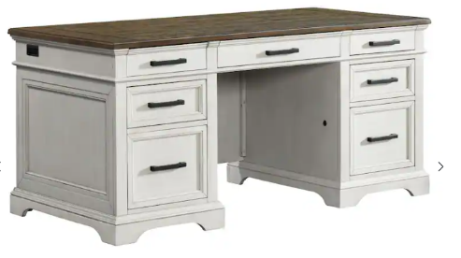 | Cost Per Item ________________________  Cost x 8 _____________________________  Freight_______________________________  Delivery date _________________________
LF-1 | Lateral File Cabinet | Intercon | DK-HO-4230LF-RFO-C (Drake Collection) | 8 | — | Rustic White & French Oak | 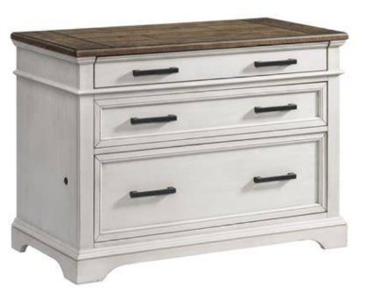 | Cost Per Item ________________________  Cost x 8 ______________________________  Freight_______________________________  Delivery date _________________________
CH-2 | Task Chair | Serta | Smart Layers Brinkley Ergonomic Bonded Leather Executive Office Chair | 20 | — | White | 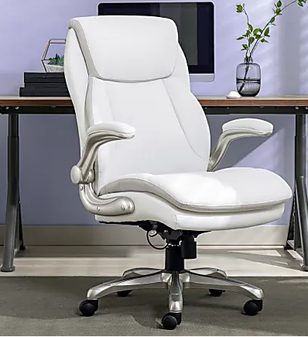 | Cost Per Item ________________________  Cost x 20 ____________________________  Freight_______________________________  Delivery date _________________________
CH-4 | Accent Chair | EROMMY (Substitute model due to limited availability) | Modern Upholstered Faux Leather Tufted Armchair Linen Accent Chairs (Bed Bath & Beyond #35053146) | 13 | Color assignments by room:• Blue – Office 138• Yellow – Office 139• Light Blue – Office 135• Orange – Office 136• Green – Office 137• Gray – Office 128 | Linen / Faux Leather  EROMMY (Substitute model due to limited availability)  Modern Upholstered Faux Leather Tufted Armchair Linen Accent Chairs - On Sale - Bed Bath & Beyond - 35053146 | 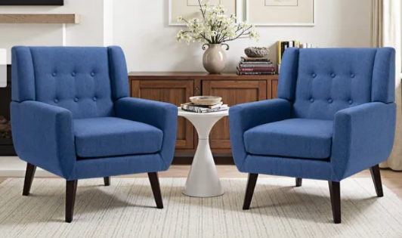  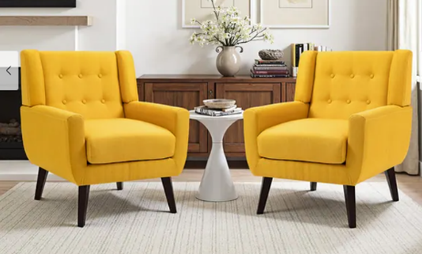  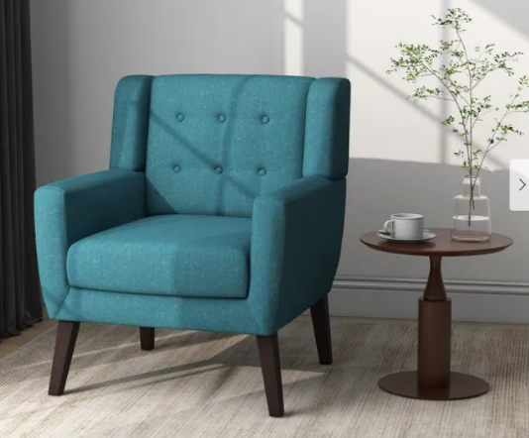  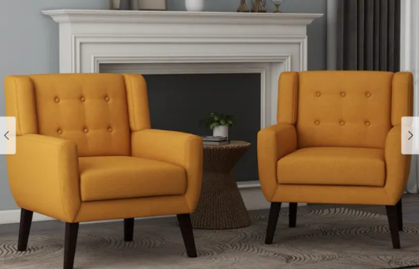  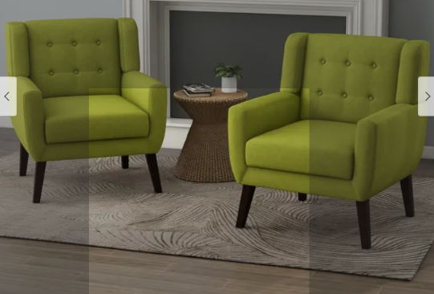  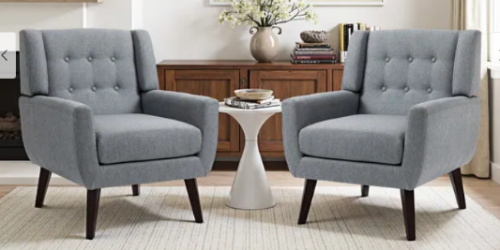 | Cost Per Item ________________________  Cost x 13 ____________________________  Freight_______________________________  Delivery date _________________________
CH-5 | Task / Side Chair | Steelcase | Move Chair | 16 | — | Jungle ST167   | 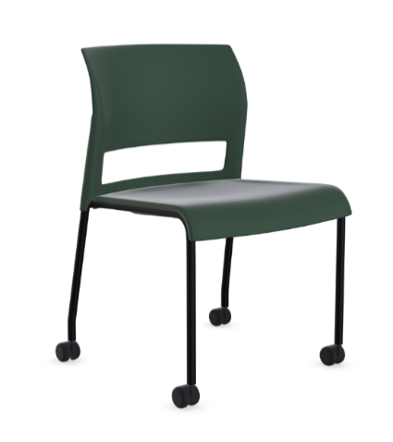 | Cost Per Item ________________________  Cost x 16 ____________________________  Freight_______________________________  Delivery date _________________________
CH-6 | Bar Stool | Steelcase | Move Stool | 3 | — | Jungle ST167   | 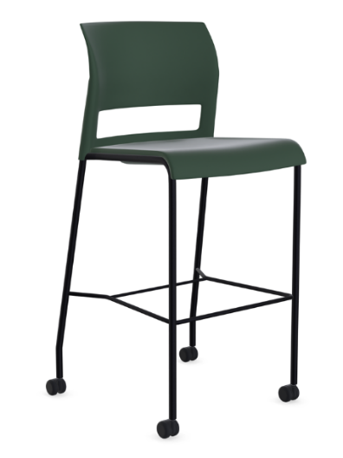 | Cost Per Item ________________________  Cost x 3 _____________________________  Freight_______________________________  Delivery date _________________________
CH-7 | Conference Chair | Steelcase | Chord Chair – Conference | 20 | High back, large scale, pillow upholstery | Black | 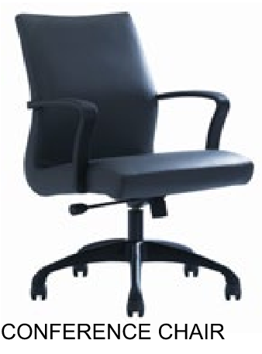 | Cost Per Item ________________________  Cost x 20 ____________________________  Freight_______________________________  Delivery date _________________________
CH-8 | Lounge Chair w/ Tablet Arm | Steelcase | Jenny Club + Tablet Arm (Left Hand) | 2 | — | Jungle ST167 |  | Cost Per Item ________________________  Cost x 2 _____________________________  Freight_______________________________  Delivery date _________________________
PF-1 | Soft Play Furniture | Wesco | Tiny Tot Module – Gigantic Kit | 2 | Use muted color tones similar to provided reference | — | 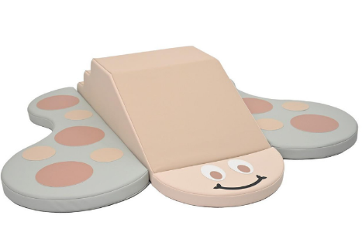 | Cost Per Item ________________________  Cost x 2 _____________________________  Freight_______________________________  Delivery date _________________________
PF-2 | Soft Play Furniture | Wesco | Highlands Climber | 3 | Use muted color tones similar to provided reference | — | 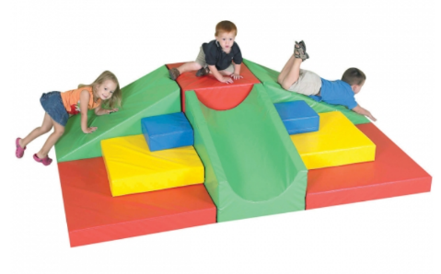 | Cost Per Item ________________________  Cost x 3 ______________________________  Freight_______________________________  Delivery date _________________________
PF-3 | Soft Play Furniture | Wesco | Tiny Tot Module – Reflection Crawl Away Kit | 2 | Use muted color tones similar to provided reference | — | 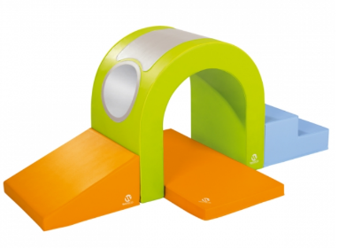 | Cost Per Item ________________________  Cost x 2 _____________________________  Freight_______________________________  Delivery date _________________________
PF-4 | Soft Play Furniture | Wesco | Blocmodule Climbing Kit | 2 | Use muted color tones similar to provided reference | — |  | Cost Per Item ________________________  Cost x 2 ______________________________  Freight_______________________________  Delivery date _________________________
PS-1 | Modular Stage | Wenger | — | — | Use muted color tones similar to provided reference | —

Company Name ___________________________________________________________________________________________

