Cherokee Nation

**www.cherokee.org**

**REQUEST FOR SEALED BIDS**

**ICW BUILDING RENOVATION**

**(CHEROKEE COUNTY)**

**ADDENDUM 02**

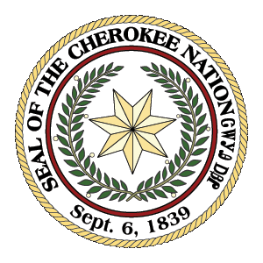

**Cherokee Nation Procurement Department**

**On behalf of Planning and Development**

**CHEROKEE NATION**

**P.O. Box 948**

**Tahlequah, OK 74465**

**(918) 453-5000**

**REQUEST FOR SEALED BIDS**

**ICW BUILDING RENOVATION**

**(CHEROKEE COUNTY)**

**ADDENDUM 02**

Any remaining questions or requests for information not provided in Addendum 01 for this project are included in this Addendum 02 including updated specifications and drawing sheets.

Link: [ICW Building](https://blueriverarchitects-my.sharepoint.com/:f:/p/cseat/EsxjYYxBypxDqQFZRPG2QBgBYHCb9yZ_jvYM_ZabsxG0-g?e=WYXECH)

Highlight link, right click, select Open Hyperlink.