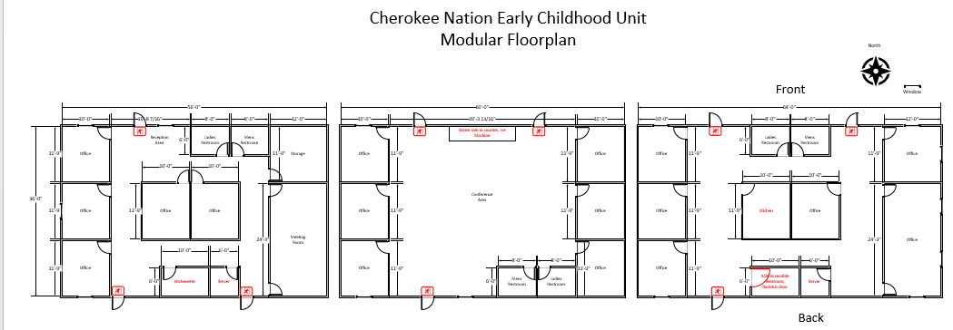

Front

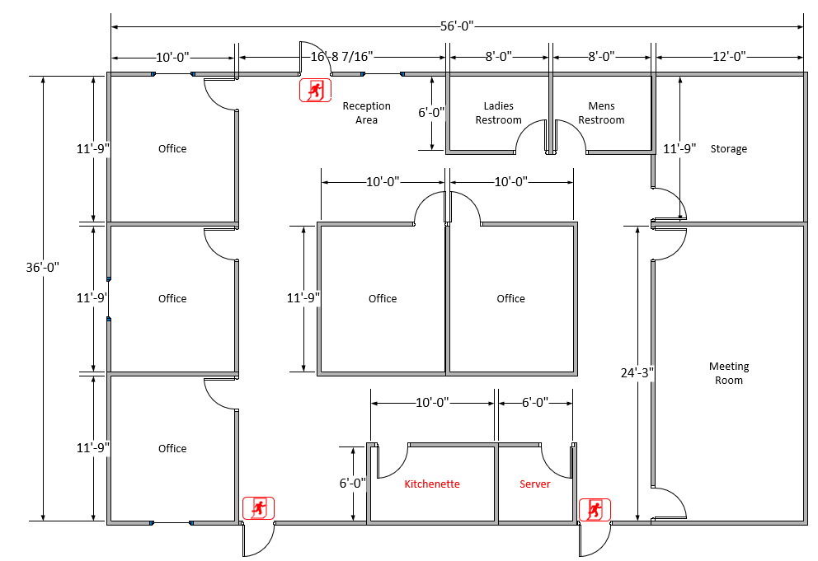

Back

Front

Back

Front

Back