Statement of Work

|  |  |
| --- | --- |
| Date | 5/6/2024 |
| Client | Cherokee Nation Entertainment (CNE) |
| Job Name | Machine Entry Authorization Log (Meal Books) |
| Requested by | Carla Davies |
|  |  |

Summary

Cherokee Nation Entertainment is requesting bids for 121 Machine Entry Authorization Logs. **Must be licensed through the Cherokee Nation Gaming Commission CNGC and the Oklahoma Horse Racing Commission OHRC.** Books will be printed double-sided, 1 color with 92 pages including the cover. Books must be scored, folded, collated and saddle stitched.

Project Scope



The winning bidder is expected to provide

**Components:**

1. **Vendor Provided**

**121 complete meal books with the below specifications.**

Key Requirements

* Gaming Meal Books
* 5.5” X 8.5”
* 92 pages including cover
* Cover : 80# white gloss
* Inside: 50# offset white
* Score cover – fold – collate – saddle stitch
* Prints double sided – 1 color black
* See attached pictures

**Statement of Deliverables**

Please provide shipping costs for delivery to the below locations. Once we review shipping we will determine if one bulk shipment is needed or if we will be shipping to all locations.



**Examples**

**Front Cover**

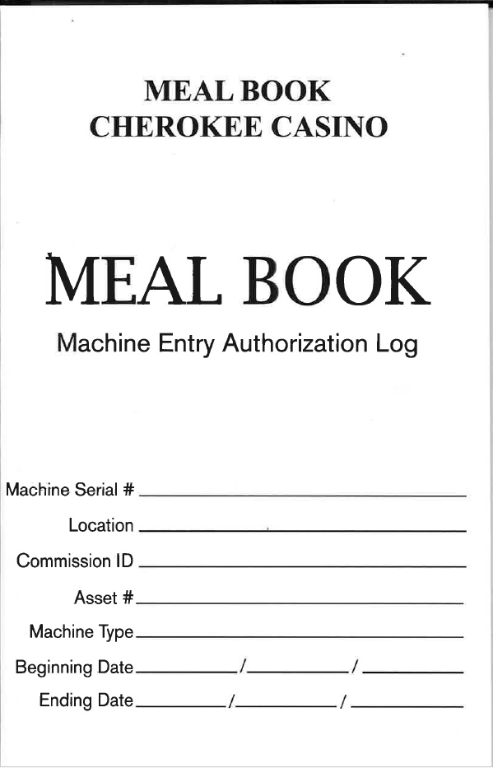

Inside

