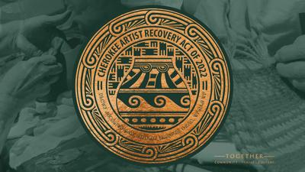

Request for Art Proposals – Cherokee Artist Recovery Act
Public Art Installation – Original 2D/3D
Cherokee Nation Complex Seal – Tahlequah, OK

Summary
The COVID-19 pandemic has had a significant impact on the livelihoods of Cherokee artists. The temporary closure of art galleries and the cancellation of art shows and exhibitions have severely affected their income.
To help Cherokee artists, rebound culturally and economically, the Cherokee Artist Recovery Act includes funds for the acquisition of Cherokee art. In accordance with this act, Cherokee Nation Businesses (CNB) is accepting bids for original art to display within several locations throughout the Cherokee Nation reservation including, but not limited to, Cherokee Nation properties, Cherokee Nation Businesses properties, and Cherokee Nation Entertainment properties.
CNB only accepts bids from Cherokee Nation citizens who can provide identification and artists previously designated as Cherokee National Treasures.

All artwork selected will receive a label to accompany its future display and will include the Artist Recovery Act insignia and supplemental text “Property of Cherokee Nation- Acquisition made possible by the Cherokee Artist Recovery Act of 2022.”

Description
The Cherokee Nation is seeking a public art installation of a large-scale Cherokee Nation seal using the current official seal of the Cherokee Nation, as well as an opportunity for accompanying artwork for the lobby area within the W.W. Keeler Tribal Complex. The Complex lobby area is a high-visibility site, with photo-ops, executive signings, and other events with the Principal Chief, Deputy Principal Chief, Tribal Council members, etc.
The Cherokee Nation seal must be no smaller than 5’ in diameter that can be constructed with multiple 3D elements such as copper, steel, wood, clay, etc. within the seal. Design must include the official seal of the Cherokee Nation.
The two artworks that will be displayed on each side of the Cherokee Nation seal must be no smaller than 2’ in height constructed from any mixed mediums. Artist is encouraged to propose a depiction of cultural, historical elements, and/or illustrations of the Cherokee story.

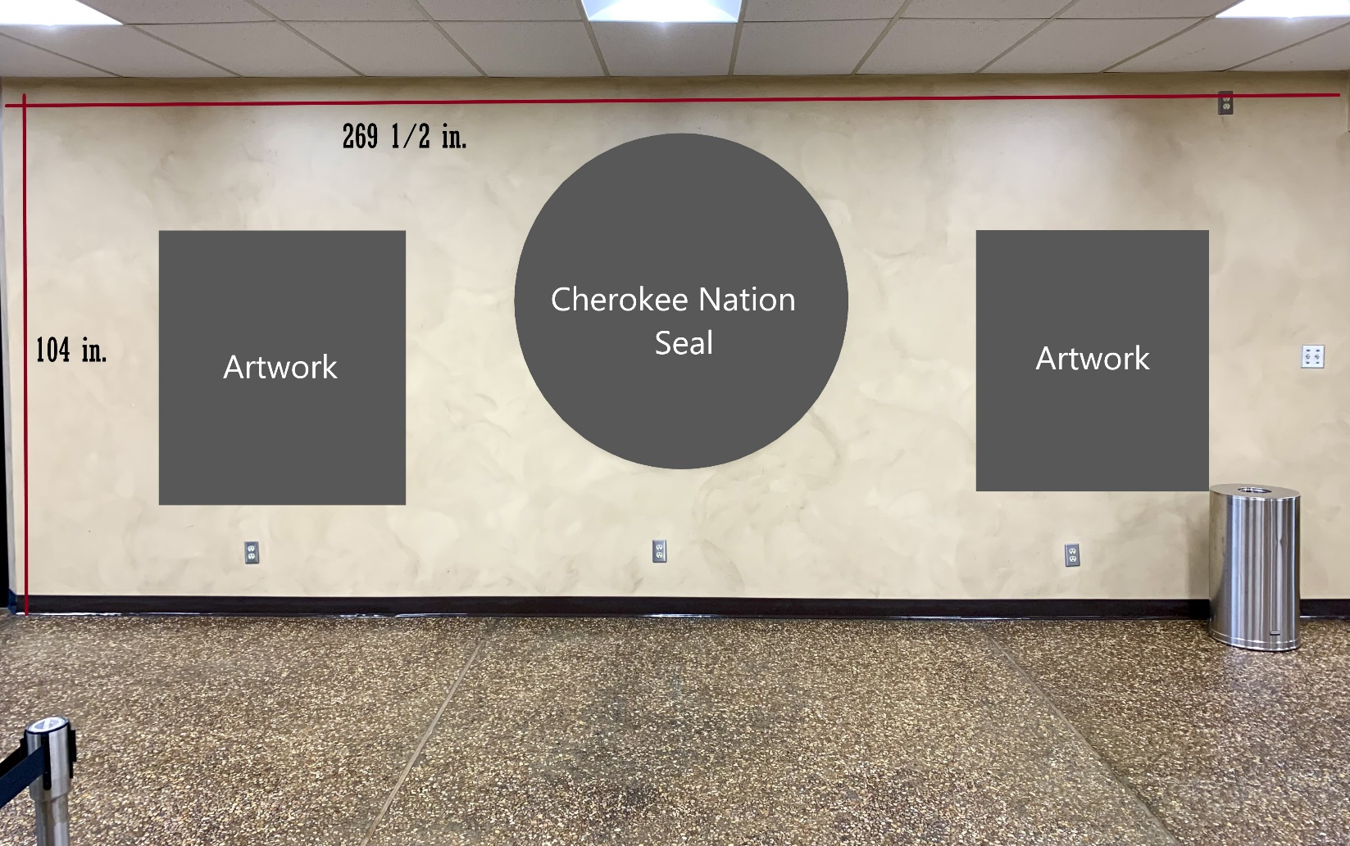

Proposal Overview
Project Proposal should include:
- Conceptual rendering of proposed installation, including proposed mediums with proposed dimensions
- General approach to project
- Proposed project schedule with key milestones, including installation timeline.
  - Artist(s) may submit bid as a phased approach if providing details of what will be completed during each phase.
- If proposing as a team of 2 or more artists, the following must be included:
  - A project lead as the general contractor and a list of other artists as subcontractors
  - Cherokee Nation Businesses will hold contract with the project lead, who will work directly with Cherokee Nation Cultural Tourism staff to coordinate artwork and installation.
  - All team members must be citizens of the Cherokee Nation or previously designated Cherokee National Treasures
- Projected cost estimate with a breakdown of associated costs such as labor, materials, and artist fees (broken down per artist, if applicable)
- Artwork will apply to all safety standards and structural requirements.

Proof of Citizenship
Cherokee Nation law requires the purchase of art from Cherokee Nation citizens or previously designated Cherokee National Treasures only. You must submit a copy of your Blue Card, Citizenship Card or proof of Cherokee National Treasure status when submitting a bid. No exceptions.

Proposal Review
Proposals will be reviewed based on overall concept, expertise of project team, potential for total project execution, and price.

Bid Information
Deadline to submit proposals is 4:00 pm on Friday, May 31st, 2024, to: Amy Eubanks, CED Buyer, at 1416 Wildcat Lane, Building A; Tahlequah, OK 74464.
Deadline for completion is 4:00 pm on Friday, November 29th, 2024, to: Amy Eubanks, CED Buyer, at 1416 Wildcat Lane, Building A; Tahlequah, OK 74464.
If you would like to drop off your submissions in Tahlequah, please submit to Devin Dry at 591 Main Parkway, Tahlequah, OK 74464.

Designs can also be digitally submitted, by the deadline, by emailing those to amy.eubanks@cn-bus.com.

