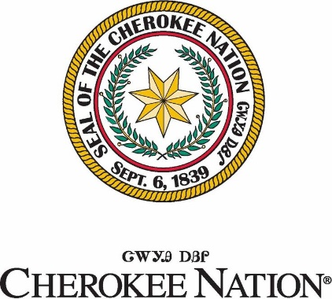

Call for Art – “New” A-Mo Health Center in Salina, OK

Original 2D and 3D art

Mayes County - Cherokee Nation

**Summary**

Cherokee Nation Cultural & Economic Development is currently accepting digitally submitted bids for 3D and 2D art to enhance the beauty of the Cherokee Nation Health Services facility in Salina, Oklahoma within Mayes County.

With its additional 77,000-square feet, the new health care facility will include a half-mile walking trail, a 15,000-square-foot wellness center, a dozen primary care exam rooms, a helipad, a drive-thru for community vaccinations, a demonstration kitchen, physical therapy services, a two-lane drive-thru pharmacy, expanded optometry care and 12 dental chairs.

Cherokee Nation Cultural & Economic Development only accepts bids from Cherokee Nation citizens who can provide identification and artists previously designated as Cherokee National Treasures.

**Description**

Artists are encouraged to submit artwork related to Cherokee history, culture, and heritage. Artwork that includes cultural or historical elements, including but not limited to historic figures, clothing, language, and symbolism should be historically and culturally accurate. Artists are also encouraged to submit artwork in contemporary styles and mediums.

Submissions will be reviewed for selection by a committee.

Example themes may include, but are not limited to the following:

* Cherokee traditional stories
* Animals and plants important to Cherokee history and culture
* Depictions of the seven clans
* Traditional cultural practices such as stickball, stomp dance, etc.
* Traditional southeastern symbolism
* Cherokee language
* Interactions between multiple generations
* Contemporary themes

**REQUIREMENTS**

* Artists’ submissions should include image of artwork, dimensions, medium, and price. A form will be provided for digital submissions.
* Artists are allowed to submit a maximum of 20 pieces.
* No “personal” photos will be accepted.
* Artists that submit their work with syllabary will be subject to having our translation team review for accuracy.
* Artists’ work will be subject to a review of cultural authenticity.
* It is the artist responsibility to mail or deliver the art if selected.
* We will only accept **completed** works of art.

**Proof of Citizenship**

Cherokee Nation law requires the purchase of art from Cherokee Nation citizens only. You must submit a copy of your Blue Card or Citizenship Card when submitting an initial proposal. **No exceptions**.

**Bid submission:**

Bids will be accepted digitally.  **Deadline for this bid is March 7th, 2025, at 5pm.**

**Bid information for digital submissions:**

Bids can be submitteddigitallyto CED Senior Buyer, Amy Eubanks at [amy.eubanks@cn-bus.com](mailto:amy.eubanks@cn-bus.com). If you have any questions, please contact Amy Eubanks via email or at (918) 422-6593.

* Digital bids must include the following:
  + Title
  + Price
  + Description of the work
  + Medium
  + Dimensions
  + **Art form filled out for each piece submitted.**
  + **Citizenship card copy.**