Uniform Scope

Summary

Contact
- Vendor will provide one contact for all CNE serviced sites.

Uniform Insurance/Requirement
- Shirt/Jean/Pants replacement must be new or like new.
- Replacement Requirements
  - No stains
  - No tears
  - No patches
  - Not faded, dungy, or dirty appearance

Pricing Breakdown Requested
- Uniform Service (Weekly)
  - Cleaning (Washing)
  - Pressing (Light, Wrinkle Free)
  - Delivery

Delivery Location and # Employees (55 Total)
Hard Rock Total - 33
  - HVAC – 9
  - Plumbing – 6
  - Central Plant – 11
  - Electrical – 7
West Siloam Total - 8
  - HVAC – 2
  - Central Plant – 5
  - Electrical – 1
Roland Total – 7
  - HVAC – 2
  - Plumbing –
  - Central Plant – 5
Tahlequah Total – 4
  - HVAC – 3
  - Plumbing – 1
Jay Laundry Total – 3
  - HVAC – 2
  - Plumbing – 1

Department Breakdown
Electrical
- FR Jeans
  - Quantity – 11
- Shirts
  - Uniform Polo Style Shirt (100% Cotton or non-melting material equivalent).
    - Uniform Shirt Style – (Employee choice on option or mix match)
      - Short Sleeve
      - Long Sleeve
    - Quantity – 11
    - Color – Grey
  - FR Shirt
    - Style – Long Sleeve Pullover
    - Quantity – 3
    - Color – Grey
HVAC
Jeans/Pants – Not required.
Shirt – Button Up Short Sleeve Lightweight Work Shirt
- Button Up Short Sleeve Lightweight Work Shirt
  - Quantity – 11
  - Color – Grey
  - Button up style shirt with two pockets.
  - Employee Department Badge on left chest
  - Employee Name Badge on right chest
  - Unform Shirt Options (Employee choice on option or mix match)
    - Short Sleeve
    - Long sleeve
    - Extended Length
FR Shirt
- FR Shirt
  - Style – Long Sleeve Pullover
  - Quantity – 2
  - Color – Grey

Central Plant & Plumbing
Jeans/Pants – Not required.
FR Shirt – Not required.
Shirt – Button Up Short Sleeve Lightweight Work Shirt
- Button Up Short Sleeve Lightweight Work Shirt
  - Quantity – 11
  - Color – Grey
  - Button up style shirt with two pockets.
  - Employee Department Badge on left chest
  - Employee Name Badge on right chest
  - Unform Shirt Options (Employee Choice on option)
    - Short Sleeve
    - Long sleeve
    - Extended Length
HVAC, Central Plant, Plumbing daily uniform shirt and style (Patch or Embroidery Locations)

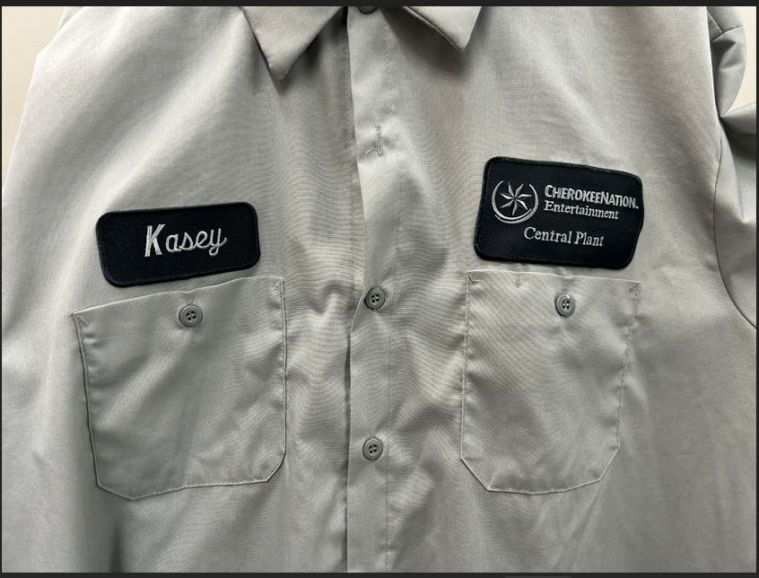

HVAC, Central Plant, Plumbing daily uniform shirt and style

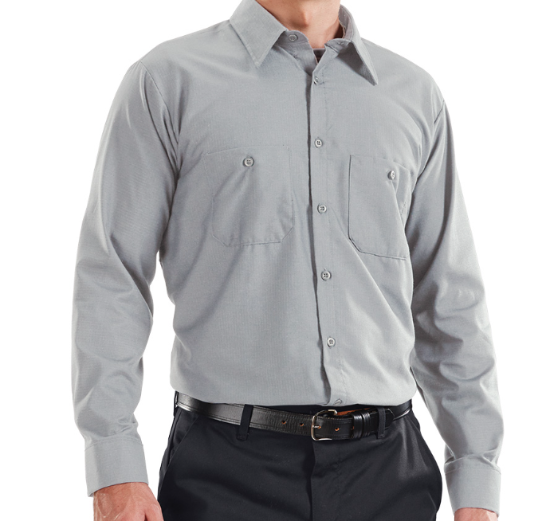

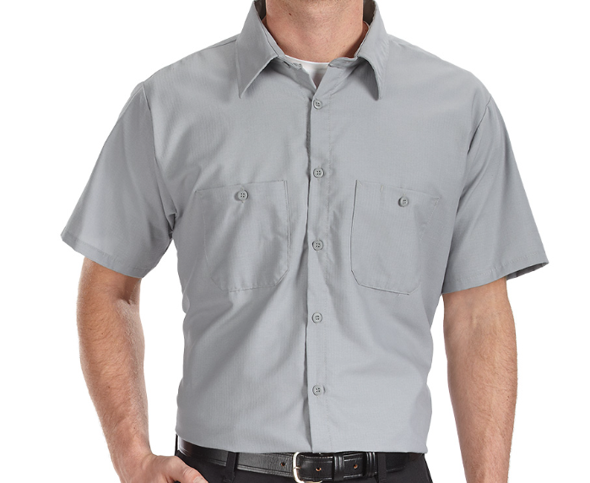

HVAC and Electrical FR Style Pullover Shirt

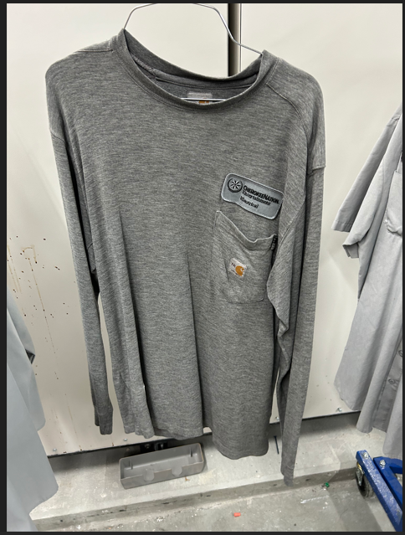

Electrical Polo Style Short Sleeve and long sleeve Shirt being requested in long sleeve and short sleeve. 100% Cotton.
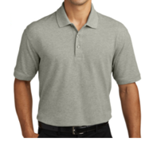

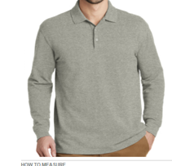

All proposals should be received by Friday, December 13, 2024 at 3:00 PM CST and can be emailed to the buyer at charla.boroughs@cnent.com . Questions about the RFP can also be emailed to the buyer at the email above.

