Statement of Work

|  |  |
| --- | --- |
| Date | 1/12/2024 |
| Client | Cherokee Nation Entertainment (CNE) |
| Job Name | Evacuation Maps |
| Requested by | Carla Davies |
|  |  |

Summary

Cherokee Nation Entertainment is requesting bids for 146 hotel evacuation maps

Project Scope



The winning bidder is expected to provide

**Components:**

1. **Vendor Provided**
   1. 146 hotel Evacuation maps

Key Requirements

* Size 11.75”X11.75”
* Color - cream
* 2nd Floor – This version and also another version with the map facing the other direction (11 of each version for a total of 22)
* 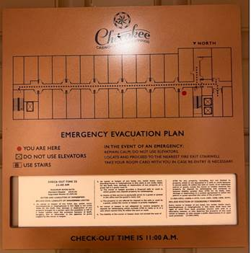
* All other floors (3, 4, 5, 6) This version and w/ map facing the other direction (51 of each version for a total of 102)
* 