Statement of Work
Date | 11/22.2023
Client | Cherokee Nation Entertainment (CNE)
Job Name | West Siloam Springs Hotel Interior Signage
Requested by | Carla Davies
Summary
Cherokee Casino & Hotel West Siloam Springs is requesting bids for replacement interior hotel door number signage and stairwell signs.

Project Scope
The winning bidder is expected to produce and install hotel door number signs and stairwell signs

Components:

- Contractor Provided
  - 140 - Guestroom number signs
  - 61 – Other door signs - example - Meeting rooms, Stairs, Business Center, Restrooms
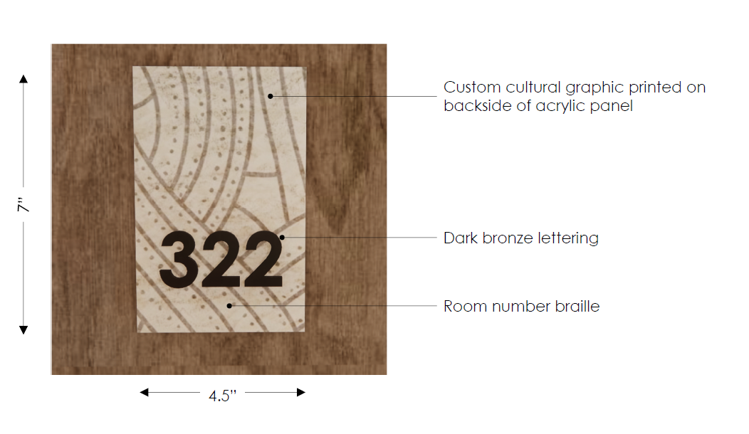

- Miscellaneous – Contractor will provide all miscellaneous components to complete the install.

Tasks:

- Installation – The contractor will install all necessary components to complete the project.
  - Conditions
    - Work schedule will be coordinated with CNE.
    - Contractor is responsible for keeping all work areas clean.
    - Remove old signage if necessary and replace with new.

