Statement of Work
Date | 11/02/2023
Client | Cherokee Nation Entertainment (CNE)
Job Name | Ft. Gibson Cherokee Casino Pylon neon Repair
Requested by | Daniel Henson
Summary
Cherokee Casino Ft. Gibson is requesting bids for repairing the broken Neon on the Pylon Sign.

Project Scope
The winning bidder is expected to replace all broken neon along with fixing any non-functioning neon. Bidder is to provide all materials, equipment, and labor required to complete the project.

Components:

- Contractor Provided

Description | QTY
Neon Repair | 1
Technicians & Equipment | 1
Labor to install | 1

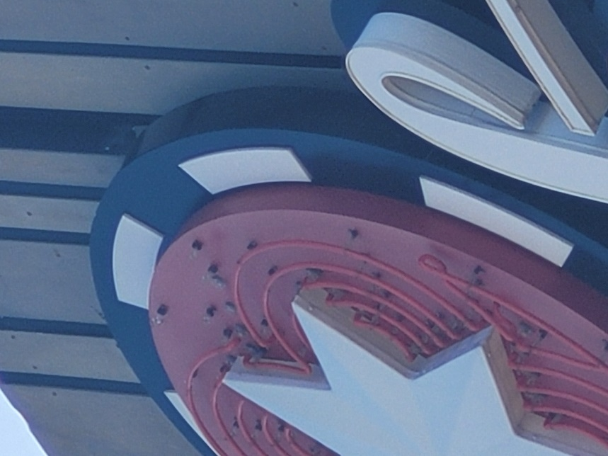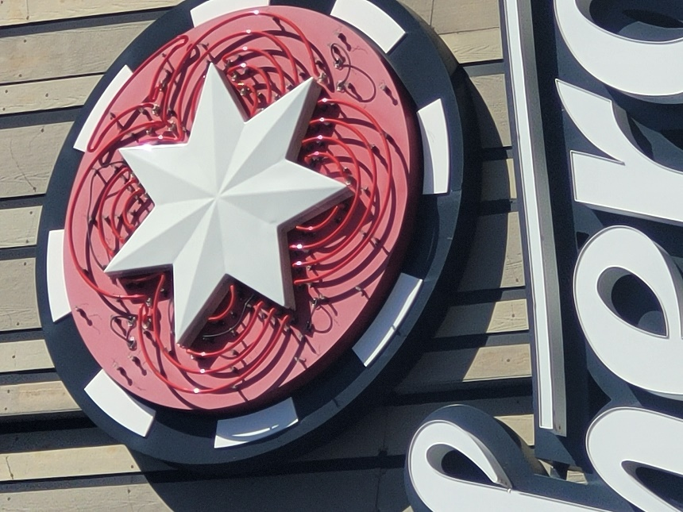

- Miscellaneous – Contractor will provide all miscellaneous components to complete the install. That includes lifts or any other major equipment.

Tasks:

- Installation – The contractor will install all necessary components to complete the project.
  - Conditions
    - Work schedule will be coordinated with CNE.
    - Contractor is responsible for keeping all work areas clean.
    - Remove broken neon and replace with new.
    - Confirm all neon is functional

  - Cabling General - The Contractor will install, terminate, and test all cabling/wiring needed to complete the project.

- Testing – The contractor will perform a complete system test and the neon should be 100% functional

Deliverables
- Haul off all removed materials and any unused components.

Key Requirements

- Contractor has all necessary tools to accomplish tasks associated with the project.
- Specified Parts:

